SB-20R TYPE G

INFORMATION
The SB-20R Type G offers impressive machining versatility within a compact footprint. The SB series main spindle platen includes six turning tools, two fixed high-speed ER11 spindles for cross working plus a further three modular cross power driven stations that accept a variety of cartridge attachments.
The flexibility of the SB-20R Type G is further enhanced by its ability to switch between guide bush mode (Swiss type) and non-guide bush mode.
The fully independent sub-spindle with C axis control coupled with driven tool capability across all four back working stations further enhances the machining capability of the SB series.
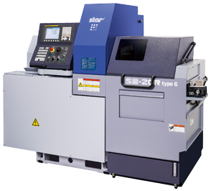

WORKPIECE
DIAMETER |  | 20MM / 22.2MM (OPT)
LENGTH |  | 205MM / 50MM
GEOMETRY
C AXIS |  | MAIN + SUB SPINDLE

BENEFITS
- Standard machining diameter 20mm (22.2mm optional)
- Maximum Z1 stroke of 205mm in Swiss mode (Guide Bush)
- Switchable between guide bush and non-guide bush modes
- Main spindle speed 10,000 rpm, sub-spindle speed 9,000 rpm
- C-axis control on main and sub spindles
- Up to 7 power tools on main spindle
- 4 Back-working power tools available
- Fully independent sub spindle for maximum overlapping
- 3 Modular (cartridge) stations on main platen
DOWNLOAD FULL SPECIFICATIONSTAR TOOLINGSTAR TV CASE STUDIESSEND AN ENQUIRY

SPECIFICATION
MAIN SPINDLE SIDE
NUMBER OF AXES | 7
MAIN SPINDLE (HEADSTOCK) | Z1 / C1 AXIS
MAIN SPINDLE PLATEN | X1 / Y1 AXIS
MAX. MACHINING DIAMETER | 20 MM / 22.2 MM (OPTION)
HEADSTOCK STROKE (SWISS TYPE / NGB MODE) | 205 MM / 50 MM
MAIN SPINDLE POWER | 3.7 KW
MAIN SPINDLE SPEED | 10,000 RPM
MAIN SPINDLE TOOLING
TURNING TOOL | 6 TOOLS @ 12 MM SQ
DRILLING ARM SLEEVE HOLDER CAPACITY | 4 X Ø 22 MM SLEEVES (ER16)
POWER DRIVEN TOOL (PDT) POSITIONS | 2 + 3 MODULAR STATIONS
MAX (PDT) SPEED | 10,000 RPM (ER11) / 6,000 RPM (ER16)
KINEMATIC DIAGRAM
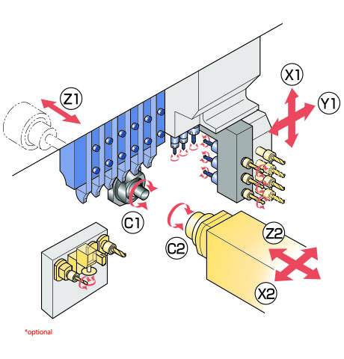

SUB SPINDLE SIDE
SUB SPINDLE |  | X2 / Z2 / C2 AXIS
MAX. CHUCKING DIAMETER |  | 20 MM / 22.2 MM (OPTION)
SUB SPINDLE POWER |  | 1.1 KW
SUB SPINDLE SPEED |  | 9,000 RPM
SUB SPINDLE TOOLING
BACK-WORKING PLATEN POSITIONS |  | 4
MAX DRILL SLEEVE CAPACITY |  | ER16
POWER DRIVEN TOOL (PDT) POSITIONS |  | 4 (ER16)
MAX (PDT) SPEED |  | 8,000 RPM
FMB | BAR FEED DIMENSION A (MM)
MICROMAG 08-20 | 3415 (1.6M) | 5015 (3.2M) | 6015 (4.2M)
MINIMAG 2-20 | 3415 (1.6M) | 5015 (3.2M) | 6015 (4.2M)
TURBO 2-20 | 3215 (2.2M) | 4215 (3.2M) | 5215 (4.2M)
TURBO 3-36 | 3320 (2.2M) | 4320 (3.2M) | 5320 (4.2M)
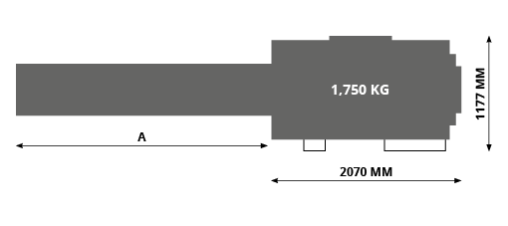

MORE INFORMATION

