2012 Rover A 1332 CNC
Serial # 35171

9080213-9070440
The Biesse Rover A represents the latest technological advancements in machining centers designed for the processing of engineered and solid woods, plastics, non ferrous metals, like aluminum and composite materials like Corian™.
Designed to play a critical role in today’s work cell and Just-In-Time manufacturing environments, the Rover A is unsurpassed in productivity, safety, reliability and operational efficiency in its class. The Rover A is manufactured by Biesse, a world leader in all types of equipment for the panel processing industry and, is supported locally in the United States by Biesse America, a totally owned subsidiary of Biesse.

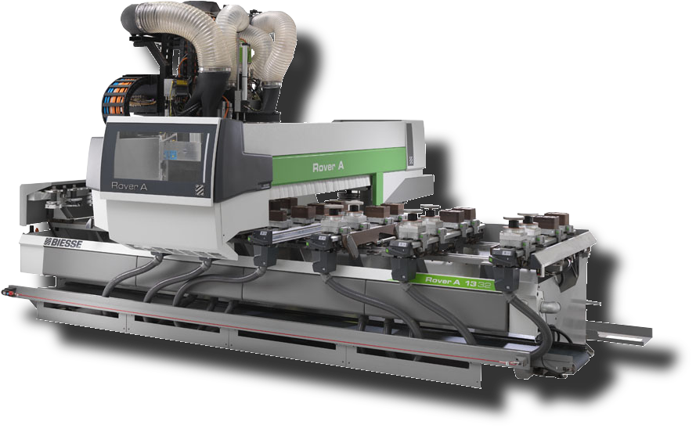
The BIESSE Rover A ATS working centers are designed with the flexibility and strengthens typical of the top level CNC Range. The double independent Z axis improves the vertical workability allowing the machine to work with high thickness solid wood parts and panels with big tool and aggregates.

As guarantee of the quality of its products and services, BIESSE has been certified ISO 9001 since 1995 and works in accordance with the UNI EN ISO 9001:2000 norms.
Most of the technological components assembled on the machining centers is produced by companies of the Biesse Group or by world-wide known companies included in the Biesse "Register of Qualified Suppliers", which have strictly cooperated with Biesse through the years.
The running tests of each machining centre include the following stages:
- Intermediate control of operating units and pre-assembled components;
- Non-stop running test for the simulation of workings, for a minimum period of 10 hours;
- Control of X and Y axes precision and positioning repeatability by means of an interferometric laser (VDI/3441 norm);
- Gauging of the X and Y axes through a software function: the values detected during the laser tests are elaborated by the N.C. and transmitted to the axes drives in order to improve the positioning precision;
- Functional tests for routing and boring operations on panels positioned on all the machine origins.

STRUCTURE
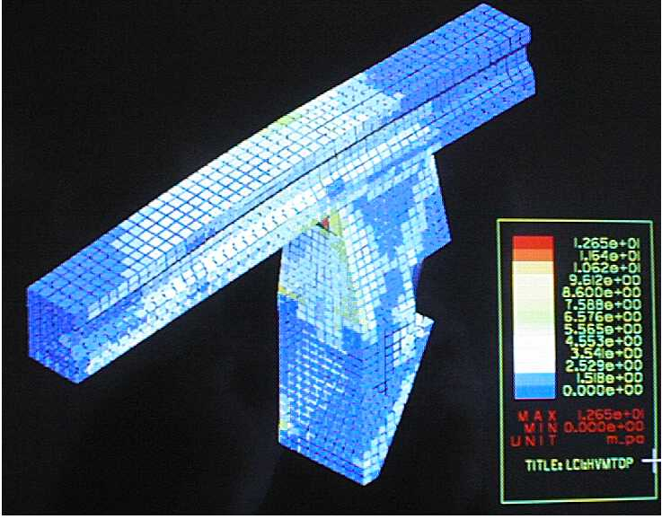
All the machine structural components have been designed with a CAD product for solid modeling which allows us to determine the possible structural distortions caused by static and dynamic loads. The correct dimensions of the most critical components are elaborated by a software for finite elements structural calculation which, by simulating the work conditions, allows to determine the most stressed areas which need strengthening.
This definition of the machine structure grants maximum rigidity, high precision in time and refined finish to BIESSE machining centers, even during heavy-duty phases.
The machine base consists of a single component made up of thick electrowelded steel sheets, suitably strengthened in the most stressed areas.
The upright, mobile in the longitudinal direction (X axis) consists of a X carriage and a Y beam, realized of an electrowelded steel structural work: thick steel sheets and strengthening transversal elements allow to reduce to the minimum the distortions produced by the use of the machining centre.
The transversal carriage (Y axis) and the vertical carriage (Z axis) consist of a casting in aluminum light alloy, they are stabilized and then machined on the machine tool with a single positioning.

MOVEMENT OF CONTROLLED AXES
The beam movement along the longitudinal axis (X axis) and the operating head movement along the Y axis are by pinion and rack, a solution BIESSE has used for twenty years which grants acceleration parameters and movement speeds greater than those obtained through a ball screw: working times are cut down, in particular for boring operations. BIESSE uses a tempered and ground rack with helical teeth and a precision reducer with single pinion. The preloaded pinion grants smooth movement and maximum positioning precision.
Both rack and pinions are in accuracy class nr. 6(DIN 3962 norm).
The operating unit moves in the vertical direction (Z axis), with a relatively limited travel, by means of ball screw and preloaded nut for backlash compensation and repeatability in positioning precision. The motorization is transmitted to the screw by means of a mechanic joint. The ball screws are in accuracy class ISO 5.

MOTORIZATION OF CONTROLLED AXES
BIESSE uses Brushless motors, controlled by digital drives.
DIGITAL interface between numerical control and axes drives. The digital system Mechatrolink grants:
- Greater machining speed, since the toolpath is partly controlled by the drive instead of the numerical control.
- High working precision, thanks to faster data processing.
- High reliability, thanks to a reduced wiring system which eliminates electrical interferences typical of analogical systems.
- Reduced machine stops and downtime, thanks to the error diagnostics with explanatory messages displayed directly on the N.C

GUIDES OF CONTROLLED AXES
All axes movements take place on sliding blocks coupled with linear guides which are made of tempered and ground steel. Each sliding block features 4 sliding gaskets to protect the bearing guides from chips and dust. The size and the great center distance between the guides grant precision and optimum finish performed by the operating units.

CONTROLS ON REMOTE KEYBOARD
Remote keyboard with potentiometer for the manual control of the axes speed, with emergency push-button and control for the tool unlocking during tooling operations.
NUMERICAL CONTROL
PC-based control system BH660.
Thanks to the new Biesse technology WRT (Windows Real Time), which increases the performances of Windows XP by making it work in real time, the machine is controlled directly by the PC, and any other hardware component becomes unnecessary.
Since the software that controls the machine runs directly on a personal computer and not on a dedicated hardware device, the system architecture is greatly simplified, grants greater performance and reliability.
Main system features
- WRT software for machine control.
- Windows XP OS with owner extension in order to manage the real time process.
- Real time interpolating axis control module.
- I/O signal management module.
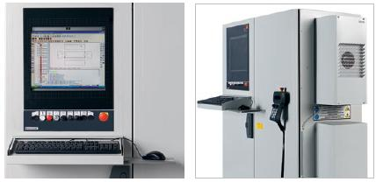
- Electronic card for Mechatrolink communication with axis driver, I/O modules and all the other fieldbus devices
- Machine function activation soft keys.

PERSONAL COMPUTER DESKTOP
Main technical features:
•CPU Dual Core 2.5 GHZ
•RAM 2 Gb memory
•320 Gb hard disk
•19" LCD screen
•keyboard
•mouse
•DVD reader
•RS-232 serial port
•USB ports
•Ethernet card to connect the machine with the office PC
These technical specifications may be subject to updates.
Since the personal computer controls the processes BIESSE does not allow the installation of additional non-authorized software, under penalty of losing the guarantee.

7000200 AUTOMATIC LUBRICATION SYSTEM
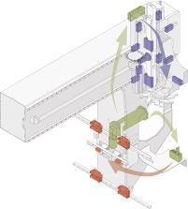
At each time interval, programmable through the numerical control, the pump automatically sends the lubricant to the following machine components, with no machine downtime and no operator's intervention:
- X axis: 4 sliding blocks of the linear guides and rack (in two points)
- Y axis: 4 sliding blocks of the linear guides and ball screw nut
- Z axis: 4 sliding blocks of the linear guides and ball screw nut
- Slots: 2 sliding blocks of the linear guide
When the quantity of lubricant in the tank is below the minimum a message appears on the n.c. screen.

9070440 WORKING FIELDS
Working Field: X = 3.280 mm; Y = 1.320 mm; Z = 170 mm with H=48 mm modules
Axis Stroke: X = 3722 mm; Y = 1993 mm; Z = 324 mm

WORK TABLE

"ATS" (Advanced Table Setting), is a BIESSE is the most advanced table design that allow easy and fast table set-up without limitations in the positioning, orientation and interchangeability of the vacuum modules.
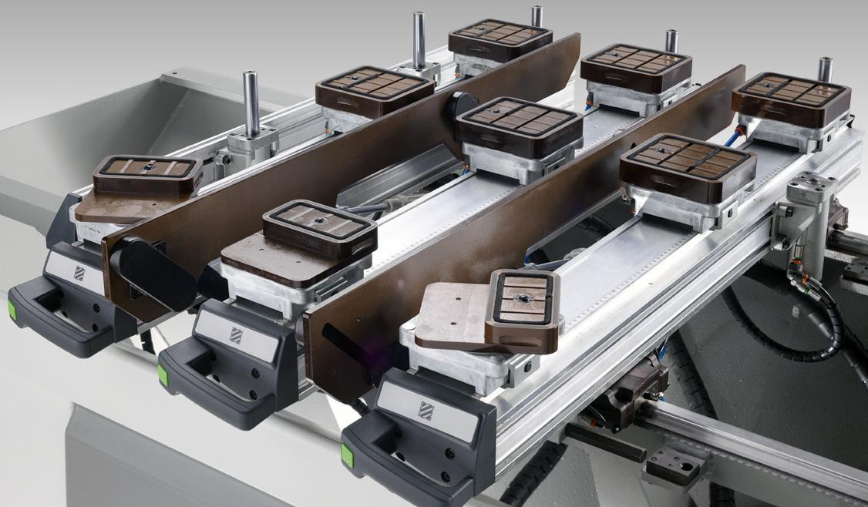
The "ATS" excels in versatility and flexibility featuring a wide range of standard and/or custom fixturing solutions
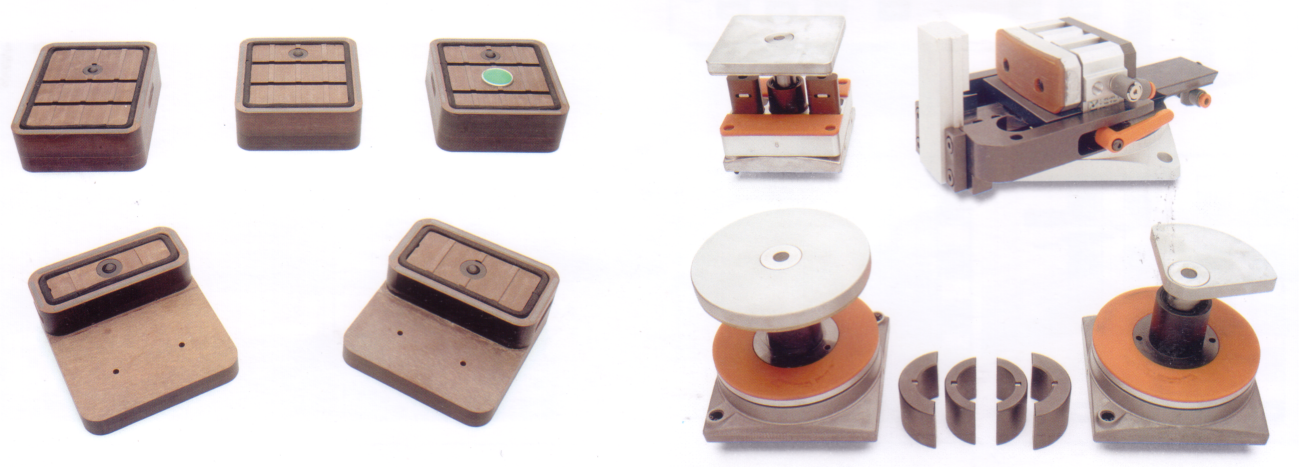
.

In the picture some of the available hold-down options not included

73006076 ATS PANEL SUPPORTS - L = 1280MM - 24 SLIDING BASES
The work area is composed of:
- 6 aluminum panel supports. The supports slide on hardened and ground linear guides by means of ball runners. The locking takes place on both the front and the back linear guide , by means of 2 pneumatic cylinders, and is controlled through a push-button placed in front of the panel support
- 1 metric scale along the "X" axis, for a correct positioning of the panel supports
- 6 metric scales along the "Y" axis, for a correct positioning of the panel locking devices
- 24 sliding bases with dimensions 132 x 132 x H 41.5 mm with independent pneumatic locking . Each base is prearranged for the installation of locking modules for pieces with different shapes and dimensions , and allows to rotate the vacuum modules by 15° , ideal solution for shaped panels
- 24 shutters for the closure of the bases not provided with vacuum modules

7350428 6 rear reference stops with a stroke of 115 mm (Back Workstation)

7350717 6 rear reference stops with a stroke of 115 mm at 1190mm (front)
Reference stops are 22 mm diameter hardened steel to grant the maximum rigidity, and on the inside top part have a tread to assemble mushroom clamps (option) or the device to reference panels with overhanging lamination (option). Reference pins can also be supplied with sensors detecting the stop position (option).

7350190 4 Side stops with a stroke of 115 mm (2 Lh + 2 Rh)
The stops can be positioned manually along the Y axis.

7350205-7350237 4 Bar supports for modules H = 74 mm.
These supports, with automatic n.c. cutting out, facilitate the loading and unloading of heavy and/or big panels.
Each support can carry a weight of 36 kg (at 7 bar).
- Pneumatic system required

7350806 Division of the vacuum system in 2 work areas in X
Division of the pneumatic locking system in 2 work areas in X
The machine total work area in X is divided in 2 independent work areas.
The activation of one or both areas is controlled by the N.C., in relation to the maximum X dimension of the active program.
Each work area can have Lh and Rh origins when removable central stops are present.
This division allows to have, on each sliding base, both the vacuum system, to be used with the vacuum modules, and the compressed air system, to be used with pneumatic locking modules such as Uniclamp modules or pushers.
* The code includes nr. 2 pedals, each activating one working area.

7350055 Auxiliary Vacuum System for custom fixtures
Auxiliary vacuum system for the use of custom fixtures through a specific machine cycle.
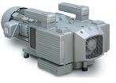
The system includes 8 quick connects vacuum ports on the machine base (4 on the LH area and 4 on the RH area).

7300971-7300918 (2) 300 m3/h vacuum pump
Rotary Vanes, Oil-free 300 m3/h at 60 Hz (176.5 cfm)

WORK UNITS
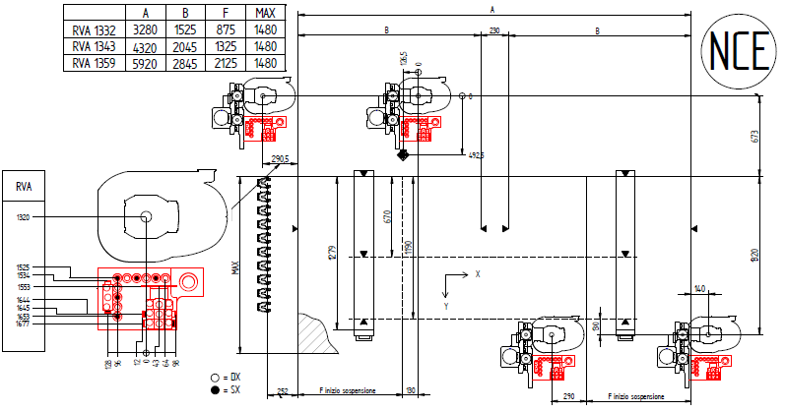
A= 3280mm (129”); B=1525mm (60”); F (full pendulum) = 875mm (34.44”)

7212116 13.2 kW (17.7 HP) ELECTROSPINDLE WITH HSK F63 ADAPTOR AND AIR COOLING
The innovative 13.2 kW (17.7 HP) Electrospindle, HSK-F63 adaptor, air cooled on the Rover machines is manufactured by HSD (High Speed Development), a Biesse Group company.
Benefits for the customer of the HSD technology:
- INCREASED PRODUCTIVITY with:
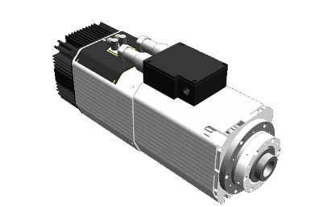
  - Programmable rotation speeds from 1,000 to 24,000 rpm
  - 13.2 kW (17.7 HP)/12,000 to 15,000 rpm in S6 duty
  - Efficient cooling system.
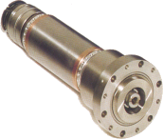
- PRECISION AND QUALITY MACHINING
  - The electrospindles on the Rover machining centers are attached directly at Z-axis carriage and extremely close to the Y-axis beam. This solution guarantees superior rigidity and is completely unaffected by the thermal expansions always present when the electrospindles are attached to the boring block effecting precision.
  - Pneumatic stroke is on a prismatic linear guide for maximum strength and precision
- HIGH PERFORMANCES AND FLEXIBILITY with
  - RH and LH programmable rotation
  - Dust hood has 6 pos., CNC adjusted for optimum dust collection in any working conditions.
  - Dust gates to redirect or close dust collection when not in use
- REDUCED MAINTANANCE with
  - Cartridge construction which allow for easy core replacement.
  - Ceramic bearings, which are less susceptible to thermal elasticity than steel bearings, thus providing increased life

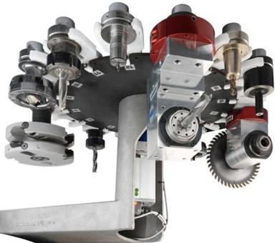
7291163 REVOLVER TOOLCHANGER 16 POSITIONS, POSITIONED ON THE X AXIS CARRIAGE
Onboard of the X axis carriage, allows to store up to 16 tools always available on each position of the machine and to perform tool changing operations in a short time.
Technical specifications:
- Wheelbase between grippers: 114mm
- Maximum loadable tools: 16 with 110mm maximum diameter
- Loadable aggregates: Refer to the toolchanger layout
- Maximum tool diameter: Refer to the toolchanger layout
- Maximum tool length: Refer to the toolchanger layout
- Maximum weight of a tool or aggregate inclusive of the tool: 7.5Kg
- Maximum total weight: 55Kg

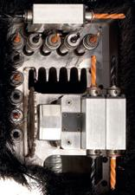

7200064 BORING HEAD BH 17 L
Working unit which can be equipped with up to 17 independent tools for single and multiple borings on 5 panel sides, and equipped with a saw blade for grooves in X direction on the panel top.
The spindles have an alternate Rh/Lh rotation and move by means of precision ground helical teeth which grant maximum operating accuracy and silence.
The head is composed of:
- 10 independent vertical spindles at a centerdistance of 32 mm, 7 of which are placed along X and 3 along Y;
- 3 independent horizontal spindles with double outlet at a centerdistance of 32 mm, 2 of which are placed along X and 1 along Y;
- 1 saw blade unit for grooves along X (dia. 120 mm, max. cutting depth 25 mm);
The spindles are driven by 1 motor controlled by inverter (motor power 1.7 kW at 2800 rpm - 3 kW at 6000 rpm): the spindle rotation speed can be adjusted up to 6000 rpm, to perform quick boring cycles and therefore reduce the working time. In addition, it is possible to choose the rotation speed according to the tools employed and the material type.
* Requires the additional Z carriage on machines with 2 independent Z axes

7212079 ADDITIONAL, INDEPENDENT Z-AXIS CARRIAGE FOR FRONT OPERATING UNITS
The Boring Block is assembled on an independent Z-axes allowing for faster change from routing to boring and vice versa.



7530075 Upgrade to BiesseWorks Advanced (machine version).

7530074 BIESSEWORKS Advanced

ELECTRICAL CABINET
The machine can be powered at 380/400/415 V - 50/60 Hz.
The electric cabinet and the inner components comply with the CEI EN 60204-1 and CEI EN 60439-1 norms.
The auxiliary transformer supplies the connection voltage for the personal computer, the air conditioner and the electrospindles cooling fans, avoiding the use of the middle neutral wire, not always available.
The electronic equipment is powered by a stabilized 24 V DC power supplier.

49720 Autotransformer for voltage different from 380 V/50 Hz.

AIR CONDITIONER FOR ELECTRIC CABINET
It allows:
- the perfect working of all the electronic components included in the electric cabinet, even at very high temperatures, up to 40°C (104°F);
- a dust-free environment, since there are no aeration fans.

SAFETY DEVICES
NON CE safety devices with low fencing
Includes:
- 1 front safety mat equipped with control unit providing internal safety – for a machine with 1 single working area
- 2 front safety mats equipped with control unit providing internal safety – for a machine with 2 working areas
- Software device to protect the operator
- Emergency rope placed in front of the machine
- Operating unit cover, made of structural and protective plates, 20 layers of overlapping plastic strips (for a total thickness of 15 mm), and a transparent panel in crushproof polycarbonate allowing operators to work in total safety since it grants maximum visibility.
- Emergency button positioned on the N.C.
- Emergency button positioned on the PC console.
- The remote control panel includes commands to operate the machine fulfilling security requirements (emergency button, tool unlocking and feed speed adjustment ...).
- Security fence: Height 1.2 m

POWER SUPPLY: 380/400/415 V - 50/60 Hz.

MACHINE STATUS
LED lights on the front hood cover provide the operation with identification of the machine status.
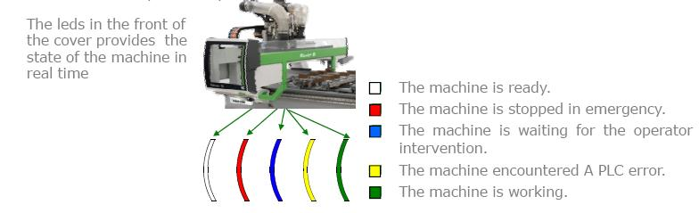

EMERGENCY RECOVERY PROCEDURE
This function allows operators to restart an interrupted working due to a machine emergency stop. The program restarts exactly from where it was interrupted, by following a specific procedure.
The working can be restarted when the emergency stop happened during.
- A work cycle with the electrospindle.
- A boring cycle.
- A cutting cycle.
- An automatic tool change on a revolving or chain tool changer.
- Any movement controlled by ISO lines.

The introduction of this function avoids having to throw away half-finished pieces, which sometimes are valuable materials (rare woods, etc.). It also allows operators to save time in case of long programs.
Not Included (please call for cost estimates):

Onsite programming training, application training or programming of customer pattern/samples

Networking
- 3rd Party software integration

Material needed for testing (panels, tooling, etc)

Local electrical requirements such as UL may require inspection by an independent agency, and the cost of any inspection and certification will be the responsibility of the customer (The machine is built in compliance with the International Electrical Code (IEC-204)

Additional training, exceeding the included installation hours, can be provided on site at standard technician daily rates plus expenses.

