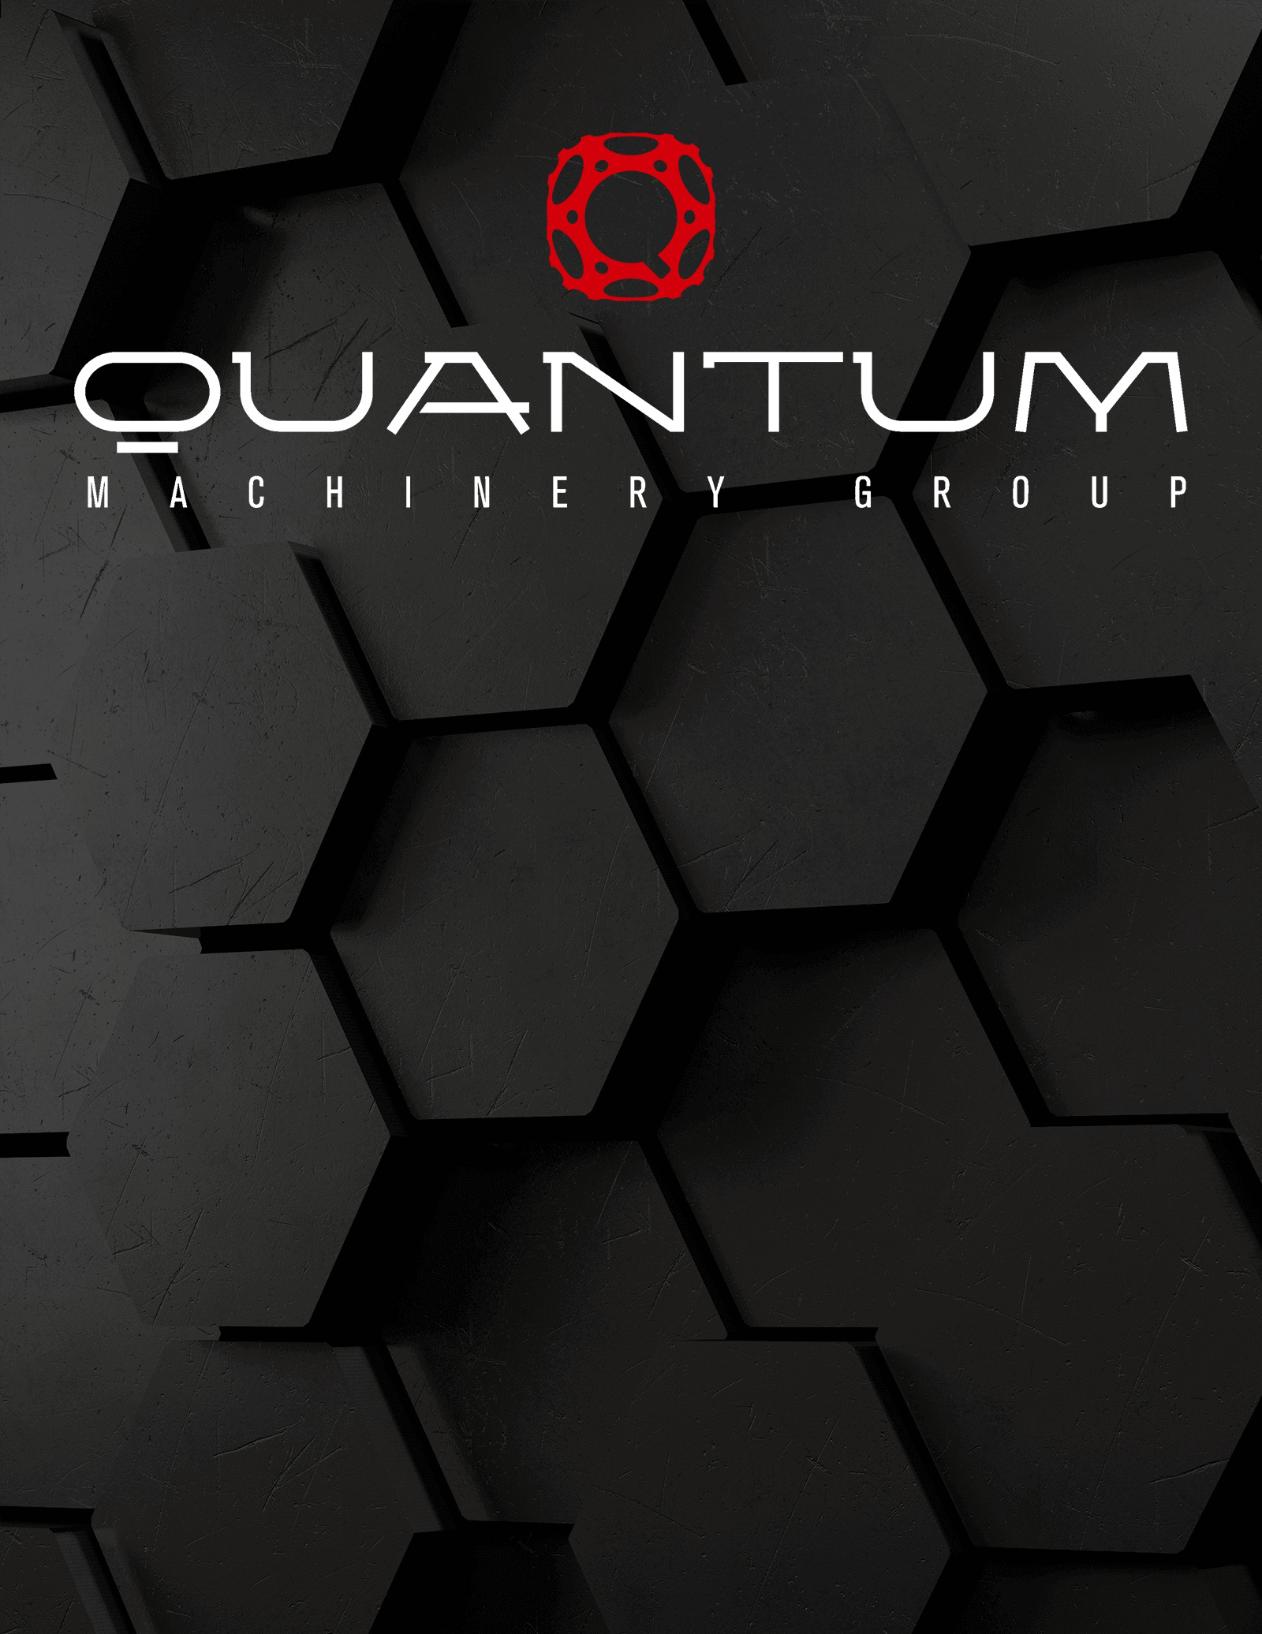

M3065I
DOUBLE-PINCH HYDRAULIC
4 ROLL PLATE BENDING MACHINE

On behalf of the Quantum Machinery Group, I am pleased to display our best offer for your review. Quantum Machinery Group is an Industry Leading Metalworking Supplier. We proudly provide creative solutions for metal forming applications to your industry. We offer free engineering support, specifying machine and tooling turnkey packages for new and existing applications, and we have our own in-house engineering department which can assist you with your profile designs along with our own tool shop using CNC lathes and CNC mills.

Successful development of technically complex and tailor-made solutions is one of Quantum MG’s core competencies. In order to find the right solution for each single customer, we are an integrated service provider, from design to delivery of the ready-to- use product needed. Together with first class plate bending technology, we offer customized services: technical training; remote and on-site maintenance; spare parts; machine upgrade and retrofitting.

We can match any type of demand on plate rolling machines design and manufacturing: useful width from 8" (200mm) up to 26.2' (8,000mm) and thickness from 0.008" up to 12".

Our Plate Rolls meet and exceed the demands of North American Industries. Covering industries such as: mining equipment, mixers, heat exchangers, boilers, pipelines, drilling rigs, water treatment, chimney tubes, air compressors, wind towers, fuel tanks, storage systems, water heaters, autoclaves, food processing equipment, coolers, structural steel, filters, pressure vessels, nuclear reactors.

Our goal is to build and maintain a long-term business relationship with you as your single source for Metal Working Machinery, Tooling, and Circular Cold Saw Blades.

Quantum Machinery Group specializes in and offers: Angle Rolls / Roll Benders, Press Brakes, Tube and Plate Laser Cutting Systems, Plate Benders / Slip Rolls, Cold Saws, Band Saws, Rotary Benders, Cutting Lines, Shears, Ornamental Working Machinery, and more!! From Basic Machines to Full-Blown CNC Machines.

QUANTUM M3065I
4 ROLL PLATE BENDER

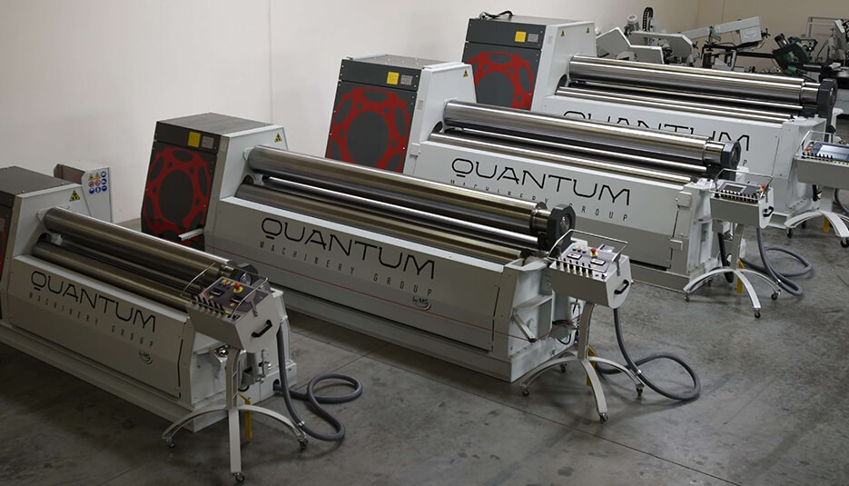
Our latest line of 4-Roll Plate Bending Machines offer many decisive advantages. The Quantum Four Roll Plate Benders are the easiest to operate plate bending machines in the market - thanks to our ability to pinch the plate between the 2 central driven rolls,
pre-bend the leading edge, and rolling the body of the part along with the trailing edge all in one direction and in one pass. The plate is kept square, without slipping, during both pre-bending and rolling cycles because of the constant clamping of the bottom and top rolls. This makes our four roll machine perfectly suited to be controlled by a NC or CNC control.

This Quantum machine is reliable and effective. Side roll parallelism is maintained by a torsion bar system which connects both ends of the roll together, eliminating the

weakness of extra encoders and hydraulic circuits. Our 2 central rolls are driven by hydraulic motors and high efficiency planetary gearboxes, coupled directly to the rolls. The Quantum solution (along with the rolls being mounted in low friction sealed bearings) greatly reduces the torque lost by clutches and synchronization systems used on other machines.

The side rolls are raised and lowered on planetary swing guides. Our perfect geometry eliminates the less efficient rectilinear gib and way systems. This allows Quantum to power the hydraulic pumps with a smaller electric motor: you get substantial energy savings without reducing the machine power or speed.

Our 4-roll plate bending machine is user friendly and very fast, thanks to a smart design able to satisfy the customer needs. Pre-bending is highly reduced because the material gets pinched by in between the two central rolls. Working can be made following the steps here below:
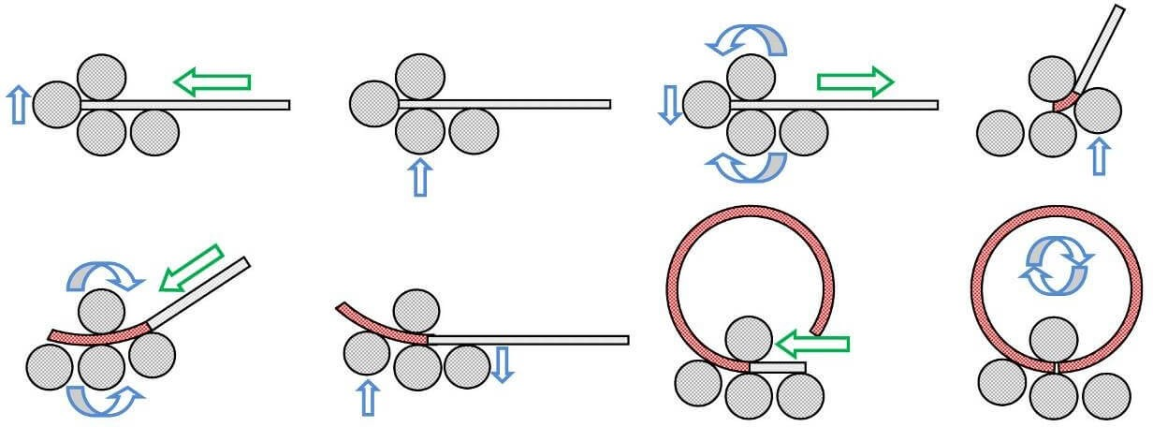

Squaring / Pre-Bending / Bending / Closing Pre-Bending (Shown Below)

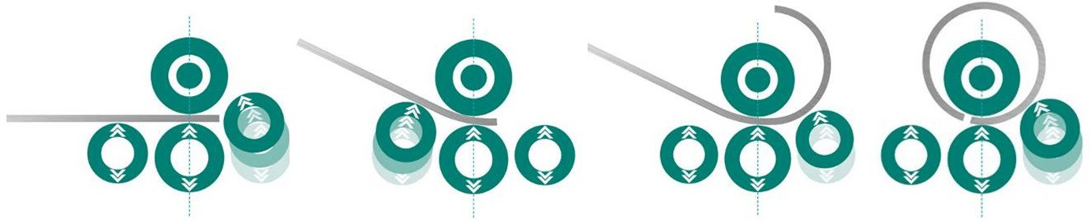

SPECIFICATIONS AND CAPACITIES

Working Length 10.17' / 122" / 3,100mm Rolling Capacity (Mild Steel) 2.55" / 65mm
Pre-Bending Capacity (Mild Steel) 1.96" / 50mm

Top Roll Diameter 24.8" / 630mm

Bottom Roll Diameter 22.5" / 570mm Side Roll Diameters 18" / 460mm
Working Height 105" / 2,655mm

Plate Roll Dimensions 250"L x 137"W Installed Power 75 HP
Approx. Machine Weight 132,000 lbs. Drive System Directly Splined on the Roll Shaft Maximum Speed 5 Meters Per Minute Hardening (Induction) 50-58 HRC
Rolls C45 Alloy Steel

Geometry Planetary

Rolls Diameter, Weight and Dimensions have to be calculated during the design phase.

The max performances are referred to shells of diameter equal or larger than3 times the top roll diameter and with material with a yield point within R = 260 N / mm².

STANDARD EQUIPMENT

Movable Console
Hydraulic system for opening the machine and ejecting the tube. Safety system to conform to EC Rules.
Electro welded monolithic structure normalized and machined on the new generation CNC boring machines.
Exclusive integrated hydraulic system developed for top performance.
Parallelism control by means of massive torsion bars to guarantee height precision also where the newest hydraulic systems fail.
Permanent lubrication system.
Planetary movement of the rolls to avoid any kind of friction and to guarantee high precision for the machine life.

PARTS USED:

All parts are selected among the best brands in the world to grant: Precision, Long-Life and Versatility.
Planetary Gear boxes By BREVINI, DINAMIC OIL (Italy)
Hydraulic Motors By SAI, INTERMOT (Italy)
Hydraulic Pumps By CASAPPA (Italy)
Hydraulic Valves By ARON, DUPLOMATIC (Italy)
Electric Parts By TELEMECANIQUE (France)
Bearing By SKF, FAG, RKB, HRB (Germany, Italy)
Forged Rolls By LUCCHINI, FMA, NUOVA OFAR, VIENNA (Italy)

MINIMUM ACHIEVABLE DIAMETER:
The minimum possible diameter to be bent depends on several factors such as:
Top roll diameter Plate thickness Material

The machine top roll diameter influences the performing of the minimum diameter for the simple fact that we won’t get a lower diameter than the top roll one.

As for the plate thickness, let’s say we are using a machine with maximum capacity 100mm, on a 3mt length. We wish to bend a plate working at the maximum capacity. In this case the minimum possible diameter we’ll get will be three times the top roll one. Let’s say now we wish to use the same machine at 60% of its maximum capacity, the case we wish to bend a 3mt plate with a 60mm thickness. At this point the minimum diameter we get will be 1.1 times the top roll one.

D min (Full Capacity) = 3 times the top roll diameter
D min (60% of Capacity) = 1.1 times the top roll diameter
Quantum Plate Bending Machines are designed and built on a basis of 260 N/mm2 yield point material.

ADVANTAGES OF THE QUANTUM PLATE ROLLS
The ultimate evolution in the plate bending field. Two dragging rolls with hydraulic pinching granting a steady and precise material dragging. This plate bending machine is the easiest, the most versatile, the most precise, and the quickest machine the market can offer.

- Automatic Simultaneous/Synchronous Balancing: Our bending rolls parallelism is controlled by massive TORSION BARS working in symbiosis with sophisticated valves controlling the oil flow . This system grants the complete and steady parallelism, in every working enviroment and conditions.
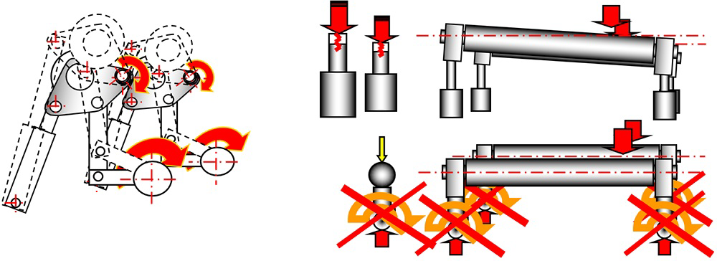

- Planetary Movements: Bending rolls planetary movement that reduces frictions at minimum, frictions very common on traditional movement machines, such as diagonal or horizontal sliding guides.
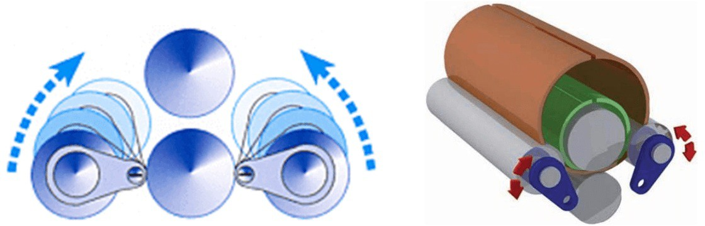

- High Efficiency and Energy Saving: We replaced low efficiency components (gears, bushings, transmission belts, sliding guides) with the best planetary / epicyclic gearboxes DIRECTLY COUPLED on the rolls and the hydraulic motors. All the machine strength is focused on the material to bend (positive strength) with consequent Energy saving and machine efficiency.

- Permanent Lubrication: All machine components are pre-lubricated and sealed following a unique system granting lubrication for the whole machine life.

- Direct Drive Motorization: Replacing of all low efficiency components (gears, bushings, mechanical gear boxes, transmission belts, sliding guides…) with the most efficient epicycloidal gear boxes DIRECTLY COUPLED on the rolls, bearings and hydraulic motors, this way all machine strength is focused on the material to bend (positive strength) with consequent Energy saving. This system conforms to the “International High efficiency and Anti-Pollution” standards.

A 4 roll plate bending machine motorization is made of two hydraulic motors, directly assembled to the rolls by particular motion transmission gears and gear boxes that gives the maximum performances with the minimum possible strength. The motion is given to the motors trough a hydraulic pump, which is set in action by an electric motor, it is successively given to the inductors and then to the rolls.

Furthermore, motorization is very important during the pre-bending phase, it allows to position the plate at the center of the rolls with the maximum precision, without losing it. This is due to the fact that we are using a 4 roll machine, and can pinch the plate with the central rolls, thus, to get a pre-bending that will not be over 1.5 or twice the plate thickness itself.
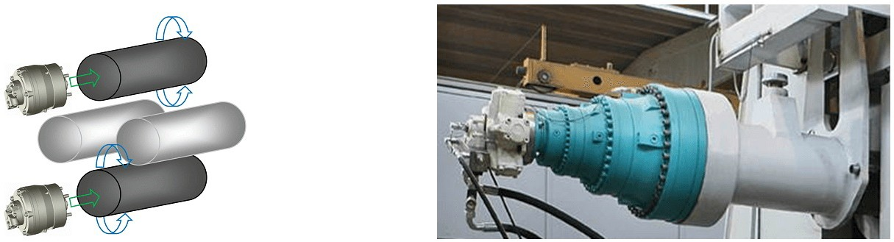

Rolls Cambering / Crowning:
Quantum's technology allows the application on rolls of a variable cambering on the basis of material thickness. Each Quantum machine is different, because its rolls do not have the same cambering / crowning. During the bending work, the rolls get subject to deflection but (thanks to the cambering) they do not reach the breaking point, and grant perfect results in their bending performance.
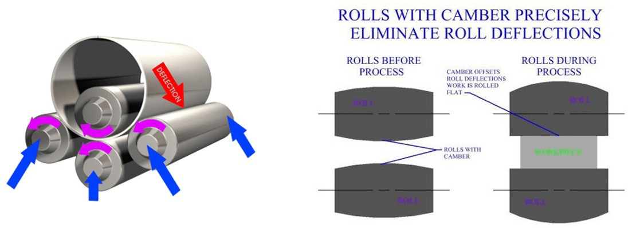

Permanent Lubrication System:
Thanks to the using of high quality and high resistance materials, can grant a system of permanent lubrication. By using autolubricated bearings it will be enough only to grease the parts during the assembling. Quantum plate bending machine’s maintenance won’t be a problem, only a periodical refilling of the oil will be necessary.
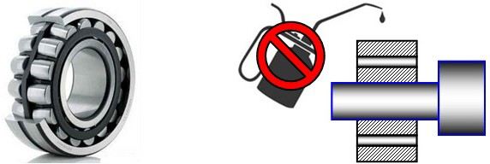

- Top Roll Contrast to Eject Pipes:
When the machine is endowed of conical bending device, Quantum Machinery uses a system called contrast to eject the pipe. Our system is composed of a piston, on the back side of the roll, that monitors the yoke position, when it’s down, the piston moves and lifts the top roll to let the operator eject the pipe without problems. The monitoring is made by a sequence valve that “feels” the pressure increasing in the hydraulic circuit when the yoke opens, transferring it to the contrast piston that lifts the roll. If the machine is CNC controlled, a pressure gauge is mounted on the sequence valve: it has the task of monitoring the pressure when the yoke closes, stopping the flow in the system.
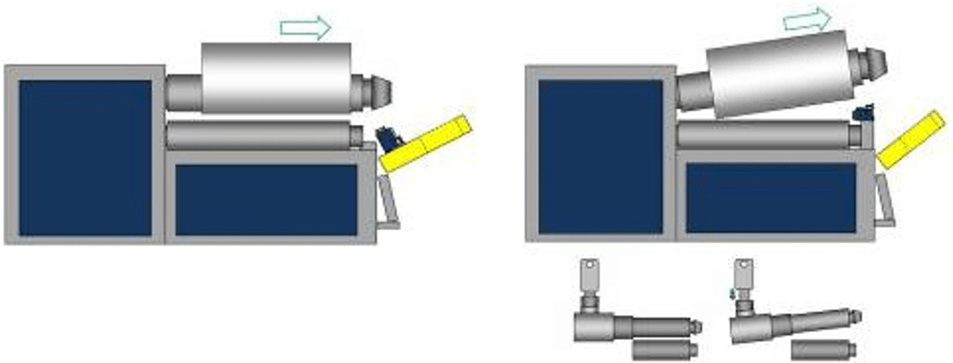

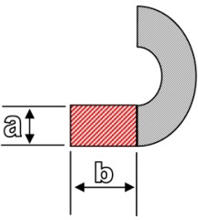
FLAT PART "The Shortest Unbent Flat":
With our plate rolling machine, the short flat part will be only 1.8 times the plate thickness. Yield point and material thickness can influence the final results, but with our Quantum Plate Rolls you always get the shortest unbent flat. See our pre-bending factors.

Conical Shapes:
Our machines have a special support, to roll a conical shape guiding the shorter edge of the plate to rotate. The best solution for bending perfect cones is our 4-roll machine with CNC: its bottom clamping roll can be tilted, to form the cone (funnel) shape wanted. Conical shapes with a conicity over 4 degrees reduce the machine performance: this is due to the unbalanced load on the top roll and its bearings.

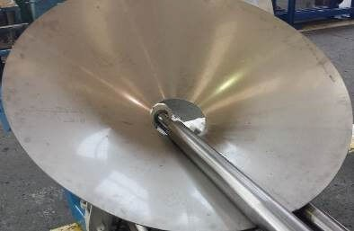
- Tight Minimum Diameters: Our planetary geometry can get the minimum possible diameter in plate roll bending. By using exclusive planetary guides, we are able to keep 50% more area of the plate under bend pressure during the rolling operation, allowing the Quantum Plate Rolls to roll down to 1.1 the upper roll diameter.

For instance: Top Roll = 300 mm > Minimum Diameter = 330 mm.

Plate thickness can influence the final result. Using a machine with maximum capacity 100mm, on a 3mt length, if we wish to bend a plate working at the maximum capacity, the minimum possible diameter we get is 3 times the top roll one. But if we use the same machine at 60% of its maximum capacity (bending a 3mt plate with 60mm thickness), now the minimum diameter we get will be very tight: only 1.1 times the top roll Ø .
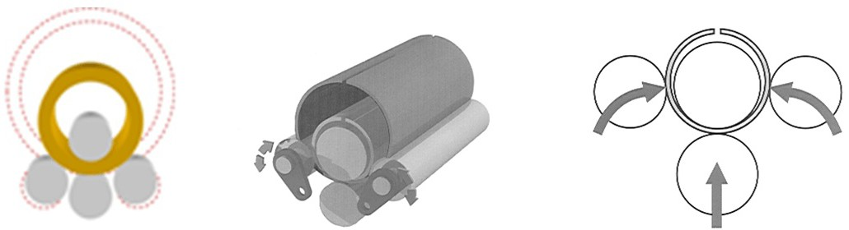

STRUCTURAL FEATURES:
Electro-welded steel frames worked on CNC working stations.
Rolls movement at variable speed from 0 to 100% (excl machines with electro-hydraulic controls).
High performance hydraulic motors, with energy saving planetary gearboxes. Immediate stopping of all moments by overcenter valves.
Variable speed shaping side rolls (not included machines with electro-hydraulic controls). Bending rolls by massive torsion bars.
Central rolls pressure setting by hydraulic valve, with the right pinching for every material thickness.
Hydraulic opening system for pipes ejection.
Top roll automatic balancing (for machine opening).
Rolls mounted on high loading bearings and double row rolls.
Pinching rolls double cambering, to correct the natural deflection of rolls during the working process.

STANDARD COMPONENTS:
Integral hydraulic system, with all hydraulic protections at EC norms.
Electrical system complete with all “overload” protections at EC norms. Mobile control console for a secure and correct position of the operator . Hydraulic machine opening for the pipe ejection.
Multiple stop system that grants the best security.

PERFORMANCE:
Pre-stations are referred to materials with a yield of 260 N/mm2.
An increase in material mechanical strength, i.e. Yield Point, or Tensile Strength, will reduce the machines pre bending & rolling capacities, by the factor ‘K’ (see chart below).
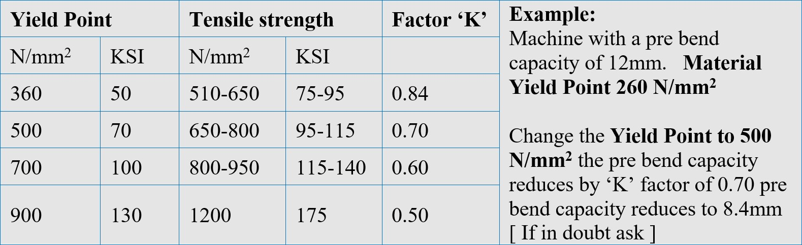

CONICAL BENDING:
Conical bending with a conicity over 4 degrees reduce machine performances. This is due to the unbalanced load on the top roll and its bearings. The more is the cone tilting the more the machine performance will decrease, till a maximum of a 50% in length and in bending thickness.
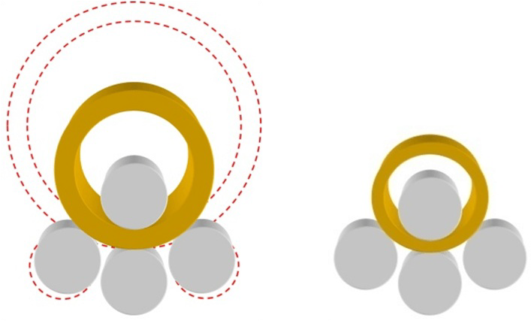
CONE UP TO 4 DEGREES: Machine Performance 92% CONE UP TO 15 DEGREES: Machine Performance 70% CONE UP TO 30 DEGREES: Machine Performance 60% CONE UP TO 60 DEGREES: Machine Performance 50% CONE UP TO 90 DEGREES: Machine Performance 40%
CONE UP TO 130 DEGREES: Machine Performance 30%

OPTIONAL ACCESSORIES

CENTRAL SUPPORT :
The Quantum Central Support has been developed to carry and help the plate in every phases of the bending process. This helps us to keep the material stable without having changing of the radiuses due to the weight of the plate.
The Central Beam is fully hydraulic and it is composed by a piston and two chains that let the movements (UP and DOWN) happens.
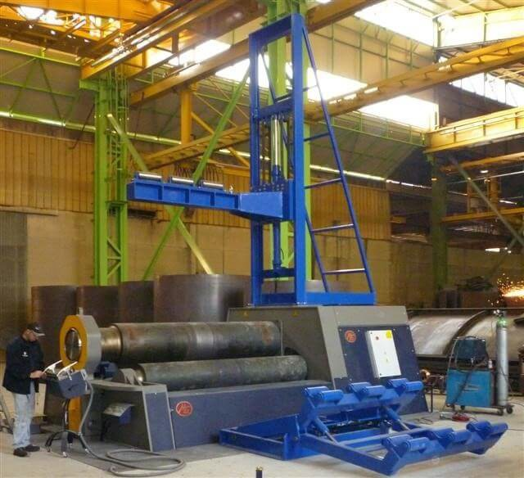
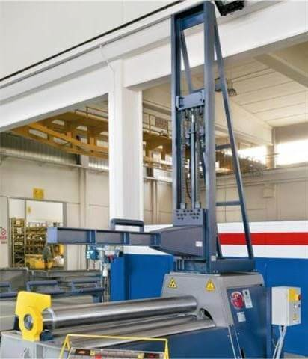

SIDE SUPPORT :
Side Support has the function to carry the plate during the bending process, in fact, during the rolling, it is possible to face problems due to the thickness and the weight of the plate. If the plate is very thin and we are going to roll a very wide diameter, the material will not favor the stability, but it will try to deform and so change its radiuses. Using a Quantum Side Support, the problem is fixed.
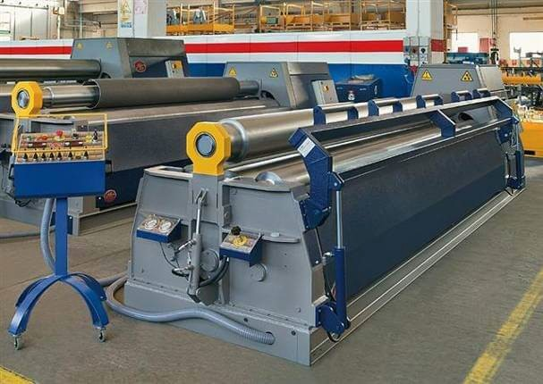

THE QUANTUM CNC EVO TOUCHSCREEN CONTROL (OPTIONAL)
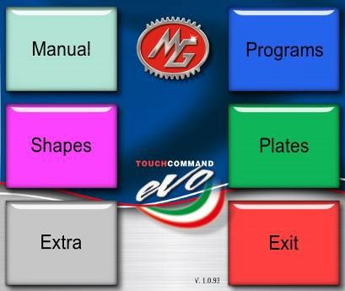
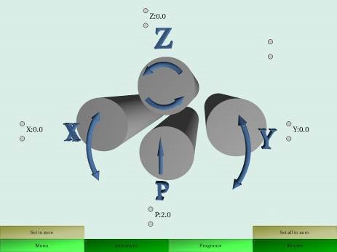
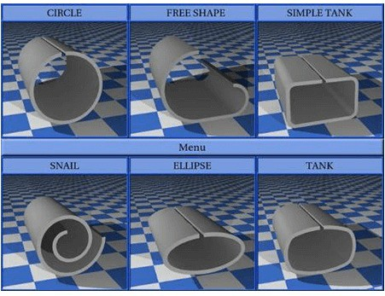

Touch Command EVO is the latest version of our CNC system completely integrated with Quantum Plate Rolls, built through years of first-hand experience. The control retains its easy to use interface that our customers have enjoyed; underneath it there is a new extremely powerful engine which delivers a precision of control never before found on a plate rolling machine. This is mainly achieved by the new closed loop system, which constantly monitors the rotation and side roll positions.

There are some challenges when it comes to designing a true CNC control for a plate rolling machine: the main one is the difference in yield tolerances of the material being rolled. Quantum has taken the unique approach of designing a material library that can be adjusted to work specifically with the material you are receiving. This is done by making test bends with your specific material and inputting the diameters that were actually achieved.

Once this is done and the computer understands how your material reacts or springs back, it can accurately auto-generate programs of virtually any shape required with the material you adjusted the library for: round, square, triangle, elliptical.

We recommend Quantum's automated controls for high volume cylinder and shell production, or to roll complex shapes that are not easily reproduced by using manual machine controls. Multiple bends, variable radius bends, ovals and the like are some examples.

This video demonstrates some of the many features, capabilities, and possibilities of the CNC Quantum EVO Touchscreen Control.
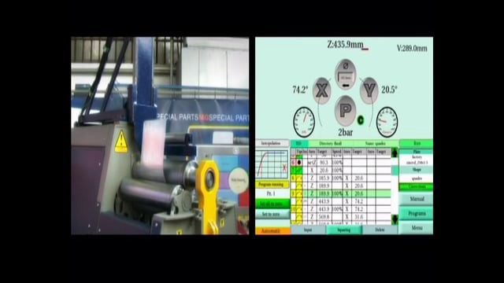

Technical Characteristics of the CNC Quantum EVO:
Programs: virtually unlimited.
Steps per program: virtually unlimited. Linux RTI operating system.
Integrated 3D graphical engine.
Quad core 1.6 GHz Arm low power fanless industrial. SODIMM DDR Memory 1 GB Industrial.
Direct connection of the LVDS LCD display. HDMI port for external monitor.
15” 5W resistive touch screen.
15” LVDS TFT new generation LCD Led display.
Front panel with 4 USB 2.0 ports and 1 RJ45 Ethernet. Automatic Synchronization Movements.
Expandible I/O for additional axes.
Closed loop proportional valves control. High speed 485 communication bus.
Automatic motor power Off for energy saving.

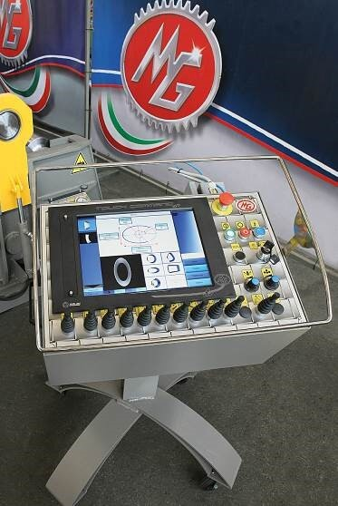
CNC Evo Features:
ASM: Automatic Syncro Movememts ITD: Interpolation Trajectory Display PBS: Proportional Bending System
OAR: Online Assistance Real Time AOI: Automatic oil Indicator
VDS: Visual Diagnostic Software CAN: CAN Communication
EPG: External program Generator VGA: Video Signal Output
USB: Ports on the Frame of the CNC
RPC: Radiation Protection Components UPS: Back Up Power Supply
TTL: Three Tests Libraries
ACF: Auto Calibration Function

Quantum CNC EVO Bending Examples
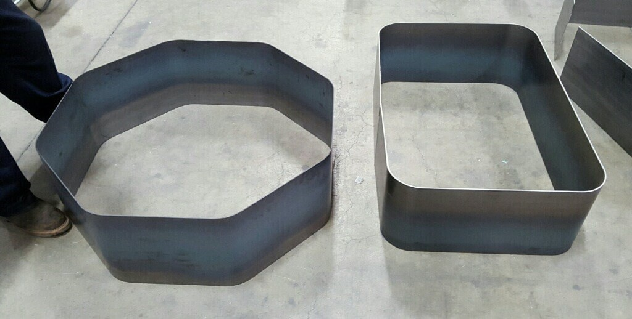
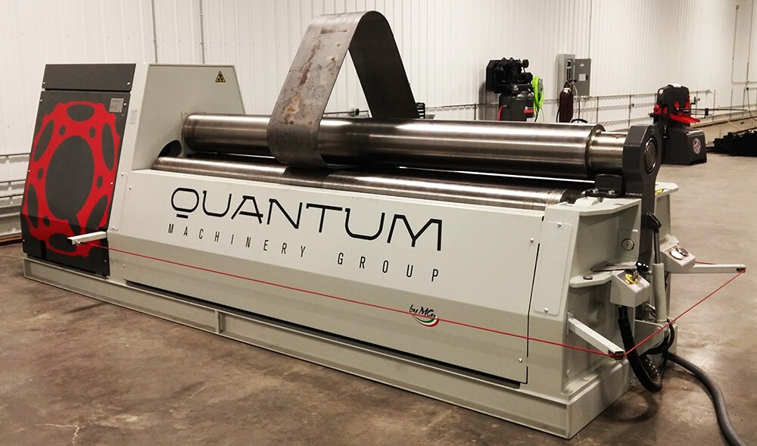

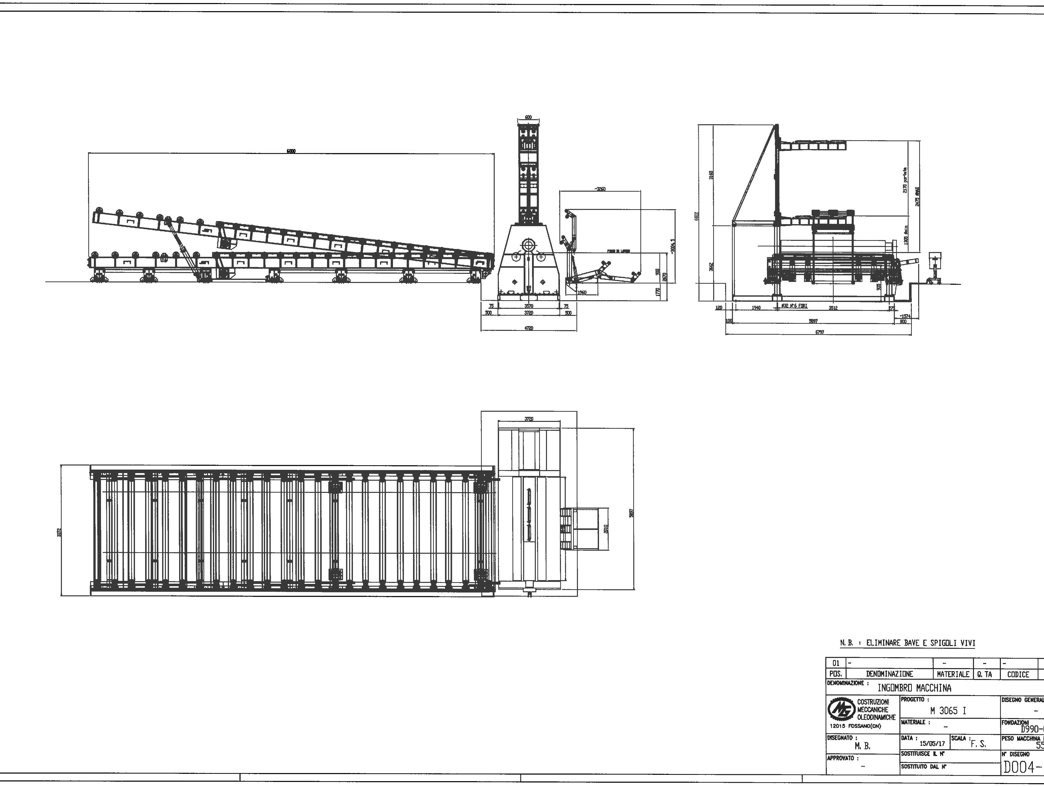
20 Foot Powered Inclined Table

GENERAL TERMS AND PRICING

Product | Price | QTY | Subtotal
M3065I - RETROFITTED 4 Roll Plate Bender  Normally $387,200  Equipped with Basic Entry-Level Control with Digital Displays Digital Displays for both Bottom Rolls  Conical Bending System Hardened Rolls  Control on Wheels Hydroelectric Calibration  Available in either 220V / 3PH or 480V / 3PH (Customer's Choice) (Machine shipped without oil - Customer is responsible for putting oil.) | $290,000 | 1 | $290,000
Quantum CNC EVO Control | $21,500 | 1 | $21,500
Double Side Arm Support (Right-Side) | $14,500 | 1 | $14,500
Top Vertical Support | $24,300 | 1 | $24,300
Brake on Motor | $7,000 | 1 | $7,000
20 Foot Powered Inclined Table (Left-Side) | $48,000 | 1 | $48,000
Shipping not included in total shown below
Subtotal $405,300

Total $405,300

AGREED TO AND ACCEPTED BY:

Once Signed and Dated, a Quantum Machinery Accounts Manager will follow up with a Sales Confirmation.

Offer Valid: Not to exceed 30 days from Mar 27, 2017

F.O.B.: Delivered to the port, customer to arrange pick up or we can deliver the containers at an additional cost.

Delivery: 2 Months Lead Time out of Factory in Italy A.R.O. and Deposit Terms: 50% With order, Balance Due prior to Shipment.

Warranty: One-year on all parts. (This warranty covers for parts only.)

Training: Quantum Machinery Group will supply a Service technician at $1,250 for training, customer is also responsible for airfare, auto, hotel and meals.

CONDITIONS OF PURCHASE AND WARRANTY

The Conditions of Purchase contained herein apply to the purchase of any machine, part of any machine, piece of equipment, or any other item, article, or device manufactured, assembled, or sold by Quantum Machinery Group. The term “Seller” as used herein shall mean Quantum Machinery Group. The term “Purchaser” as used herein shall mean any person, company, corporation, or other entity who purchases, buys or acquires, for any consideration whatsoever, anything from the Seller, Date of purchase shall be the date shown on the invoice. Should there be more than one (1) invoice for the same item, the invoice with the earliest date shall determine the date of purchase.

Notwithstanding any different or additional terms that may be embodied in your order, this acceptance is expressly conditional on your assent to the additional or different terms and conditions set forth below and on pages hereof. If these terms and conditions are not acceptable, you should notify us at once.

PRICES
Prices quoted are subject to change without notice subject to Seller’s pricing policies.
In any event prices become invalid thirty (30) days after a proposal, unless otherwise stated. Prices do not include any applicable taxes.
All prices are F.O.B. Quantum Machinery Group, Mira Loma, California unless otherwise stated.

LIMITATION OF LIABILITY – The remedies provided herein are the sole remedies of Purchaser. No oral agreement, representation, or warranty respecting said machine(s) shall bind Seller. The conditions contained herein may not be changed or terminated except by written agreement between the parties.

OTHER THAN THOSE WARRANTIES SET FORTH IN THESE CONDITIONS OF PURCHASE AND WARRANTY, SELLER EXPRESSLY DISCLAIMS ALL OTHER WARRANTIES, EXPRESS OR IMPLIED, INCLUDING WITHOUT LIMITATION, WARRANTIES OF MERCHANTABILITY AND FITNESS FOR A PARTICULAR PURPOSE WITH RESPECT TO THE PRODUCTS SUPPLIED UNDER THIS AGREEMENT. IN NO EVENT SHALL SELLER BE LIABLE FOR ANY SPECIAL, INCIDENTAL, CONSEQUENTIAL, OR TORT DAMAGES; DAMAGES ARISING FROM EQUIPMENT DOWN-TIME; OR EXEMPLARY OR PUNITIVE DAMAGES, WHETHER RESULTING FROM LOSS OF USE, DELAY OF DELIVERY, LOSS OF

PROFITS, LOSS OF BUSINESS OR OTHERWISE ARISING OUT OF OR IN CONNECTION WITH THE PRODUCTS, THE PERFORMANCE OF THE PRODUCTS, OR SELLER’S PROVISION OF THE PRODUCTS OR OTHER EVENTS RELATING TO THE PRODUCTS, EVEN IF SELLER HAS BEEN ADVISED OF THE POSSIBLITY OF SUCH DAMAGES.

SELLER’S WARRANTY – The equipment is warranted to be free from defects in material and workmanship under normal and proper usage when owned by the original Buyer. Seller’s sole obligation under this warranty is limited to replacing and repairing parts, which they may determine to be defective within the twelve (12) month warranty period. Seller will replace or repair, at its option, without charge, any part of any machine manufactured by Seller which proves to be defective in material or workmanship, provided the defective part is shipped to Seller’s factory, transportation charges prepaid, at any time within twelve
(12) months from the date of shipment, and proves to be defective upon inspection by Seller. Results of ordinary wear and tear, improper operation or maintenance, or use of corrosive or abrasive materials shall not be considered a defect in material or workmanship. Any modifications to the equipment sold by Seller, which have not been authorized by Seller, void this warranty and any product liabilities. If Seller repairs or replaces a part pursuant to the terms of this warranty, Seller’s warranty will not extend beyond twelve (12) months from the original date of purchase of the machine. In the event specifications still cannot be met, the Buyer, as its only remedy, may cancel the transaction and receive the return of any amounts paid. In no event shall the Seller be responsible for any special, incidental, consequential or tort damages, damages arising from equipment downtime, or exemplary or punitive damages, whether resulting from loss of use, delay of delivery, loss of profits, loss of business or otherwise arising out of or in connection with the goods, the performance of the goods, or Seller’s provision of the goods or other events relating to the goods even if Seller has been advised of the possibility of such damages.

DELIVERY – The shipping schedule(s) stated in the Proposal and order acknowledgment are “estimated” and shall not be construed as “firm” or “definite” shipping dates. Seller shall not be liable for delay caused by fires, floods, accidents, hazards, or transportation, strikes, labor conditions, acts of terrorism, war, domestic unrest, material shortages, including delay of material from Seller’s usual sources of supply, governmental legislation or regulations, or any cause beyond Seller’s control. In any such event, the date of delivery shall be extended a number of working days equal to the number of working days lost by the delay. Seller will consign shipments to the freight forwarding agent or other party as noted in Purchaser’s purchase order. If F.O.B. point is other than Seller’s premises, the Buyer is responsible for transportation and any damages, which may have been caused after equipment has left Seller’s premises. Buyer is responsible for unpacking and placement of equipment onto its
site.

OSHA AND ELECTRICAL CODES
The equipment covered does not necessarily comply with any codes or standards unless specifically quoted, ordered, and so accepted.
When compliance with OSHA is provided, it is based on Seller’s understanding of the construction standards in effect at that time of acceptance only.
Complete compliance with OSHA, and particularly regarding point of operation guarding, are the responsibility of the
Buyer and user and not of Seller.

ACCEPTANCE
Any offer to purchase shall not constitute an order until accepted by Seller.
Accepted orders are not subject to cancellation by the Buyer unless agreed to on terms acceptable to Seller including payment of all costs and expenses plus any deposits made up to 30% of the total amount will serve as cancellation charges.
Acceptance of the equipment shall constitute a waiver of all claims for damages caused by delay in shipment or damages to the equipment.

TITLE AND LIEN RIGHTS
Title to the equipment shall remain with Seller until the purchase price has been fully paid in cash (including any taxes or late charges).
To secure this payment, upon acceptance Buyer grants Seller a purchase money security interest on all equipment covered.
The equipment shall remain personal property regardless of how affixed to any realty or structure.

BURDEN OF RISK – All risk of damages to or loss of the machine(s) at any time after shipment from Seller’s factory is assumed by Buyer, and such damage or loss shall not in any way release Buyer from any of its obligations under this agreement. Prices do not include, and Buyer shall be responsible for, all transportation costs, excise, use, sales and other taxes.

INSTALLATION – Buyer is to make, at his own expense, all service connections necessary for the operation of any machine purchased from Seller.

WORK ON CUSTOMER’S PREMISES – If Seller’s work under this order involves operations by Seller on the premises of Buyer or one of Buyer’s customers, Buyer shall take (or cause its customer to take) all necessary precautions to prevent occurrence of injury to person or property, including personnel and property of Seller, during the progress of such work; and except as and to the extent that such injury is due solely and directly to Seller’s negligence, Buyer hereby indemnifies and agrees to defend and hold Seller harmless against all claims, demands, liabilities, or lost (including reasonable attorneys’ fees) which may result in any way from any act or omission of the Buyer, its agents, employees, subcontractors, or customers.

