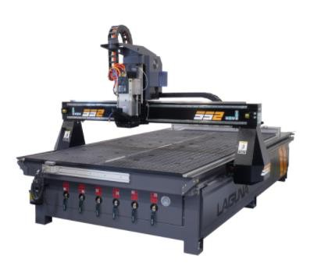
SmartShop SS2 (SS II) Manual 2021
Basic Operations-Main Screen Set-up, Set-up Menus, Machine Settings, CNC Tool Data, Delivery Protocols, Warranties, Packaging/RMA Procedures.

- SmartShop II 4’x4’-6 HP Spindle 10HP Vacuum CNC Router
- SmartShop ll 4'x8' - 6 HP Spindle 10HP Vacuum CNC Router
- SmartShop ll 4'x8' - 7.5HP Spindle 10HP Vacuum CNC Router
- SmartShop ll 5'X10' - 7.5HP spindle CNC Router
- SmartShop ll 4'x8' - 11HP HSD Spindle 10HP Vacuum CNC Router w/ATC
- SmartShop ll 5'x10' - 11HP HSD Spindle 10HP Vacuum CNC Router
Laguna Tools
744 Refuge Way
Grand Prairie, TX. 75050
Direct Phone #: (800) 234-1976
1
Warranty Repair Information: (800) 332-4094

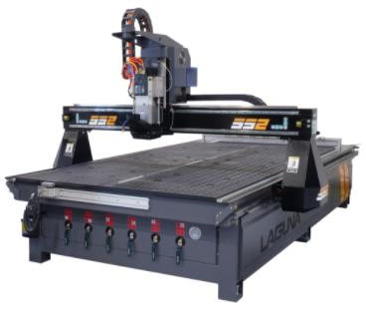
Safety Rules-

Table of Contents-
SmartShop SS2 Machine Specifications- Introduction to CNC Machines-
Introduction to CNC Machines- Glossary & Definitions Accessories, Machine Location, Unpacking & Installation- Fitting the Dust Hose-
Connecting the Vacuum Pump- Installing Router Bit-
Selecting the Correct Router Bit-
Working With Vacuum Tables and Spoil Boards- Vacuum Table T-Slots & Automatic Tool Changer (ATC)- Delivery Protocol-
Parts & Service- Laguna Tools Warranty-
Laguna Tools Packaging/RMA Procedures-
Laguna Tools Packaging/Laguna Tools RMA Example-
Laguna Tools Packaging/Laguna Tools BILL of LADING Example-

As with all machinery, there are certain hazards involved with the operation and use. Using it with caution will considerably lessen the possibility of personal injury. However, if normal safety precautions are overlooked or ignored, personal injury to the operator may result. If you have any questions relative to the installation and operation, do not use the equipment until you have contacted your supplying distributor. Read carefully before operating the machine:
Safety Rules-
- Keep the working area clean and be sure adequate lighting is available.
- Do not wear loose clothing, gloves, bracelets, necklaces or ornaments. Wear face, eye, respiratory and body protection devices as indicated for the operation or environment.
- Be sure that the power is disconnected from the machine before tools are serviced or an attachment is to be fitted or removed.
- Never leave the machine with the power on.
- Do not use dull, gummy or cracked cutting tools.
- Be sure that the keys and adjusting wrenches have been removed and all the nuts and bolts are secured.

SmartShop SS2 Machine Specifications-

 | Machine Specifications SS2
Motor Drive+A2:A39 | Delta brand VFD-E variable frequency drive.
Spindle | 11 HP HSD (Italian) Electrospindle ISO-30 (ATC), Ceramic Spindle Bearings.
Spindle RPM | 6,000 - 24,000 RPM
Controller | Laguna “Touch” Series CNC Controller. Machine features the Networking, Connectivity and online Troubleshooting. Runs industry standard "G-Code". Program transfer to the controller can be accomplished with USB, Ethernet.
Remote Dust Collector and Vacuum  Control at the Operator Station | Yes
Dust Chute Diameter | 4" Inches
Volts | 208-220 volts 1 or 3 phase
Amps | Dependent on the Vacuum Pump Selection.
X, Y and Z Axis Travel | 48" x 48" x 9.5" axis travel (4' x 4' Model)  48" x 96" x 9.5" axis travel (4' x 8' Model)  60" x 120" x 9.5" axis travel (5' x 10' Model)  60" x 144" x 9.5" axis travel (5' x 12' Model)
Gantry Clearance | 11" Inches
Machine Work Table | 48.0" x 48.0" (4' x 4' Model)  48.0" x 96.0" (4' x 8' Model)  60.0" x 120.0" (5' x 10' Model)  60.0" x 144.0" (5' x 12' Model)
Rapid Travel/Cutting Speed | 720 rapids,550 cutting
Heavy-Duty Welded Tubular Steel Frame | 3,500 lbs. - 4,500 lbs. (Depending on Model)
Machine Foot Print | 80" x 80" (4' x 4' Model)  80" x 140" (4' x 8' Model)  90" x 160" (5' x 10' Model)  90" x 184" (5' x 12' Model) `

SmartShop SS2 Machine Specifications-

 | Machine Specifications SS2
Work Envelope | 49.0" x 73.0" x 8.0" (4' x 4' Model)  49.0" x 97.0" x 8.0" (4' x 8' Model)  61.0" x 121.0" x 8.0" (5' x 10' Model)  61.0" x 145.0" x 8.0" (5' x 12' Model)
Vacuum Table with T-slots | Yes
25 mm heavy-duty HiWin HG Series linear  bearings and rails on all axis. | Yes
Helical Rack-and-pinion drives on “X” and “Y” axes and precision-ground ball screw drive on “Z” axis. | Yes
Gantry is driven on each end (two “helical” rack-and-pinion drives on “Y” axis). | Yes
Limit Switches. | Solid State
Expandable control system for custom  applications. | Yes
Spindle Speed control through  programming. | Yes
Manual overrides of Spindle Speed and  feed speeds during run. | Yes
Centralized Lubrication System. | Yes
10 HP Vacuum Pumps. | Yes
Vacuum monitoring gauge. | Yes
ISO-30 tool holders, collets and precision  collet nuts. | 30 amp
Automatic Tool Changer with 8-position  tool rack. | Yes

Introduction to CNC Machines-
Caterpillar Track (On Opposite Side).

Electro- Spindle

Gantry
ATC Tool Rack

Tool Clips

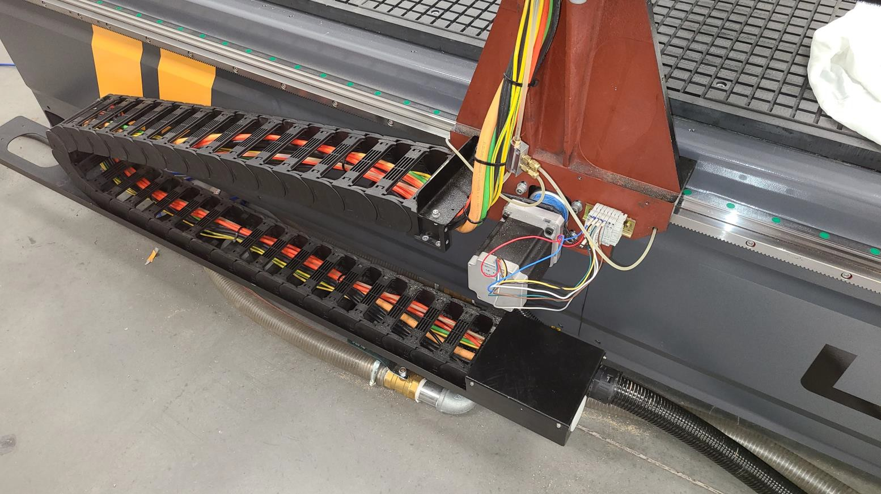
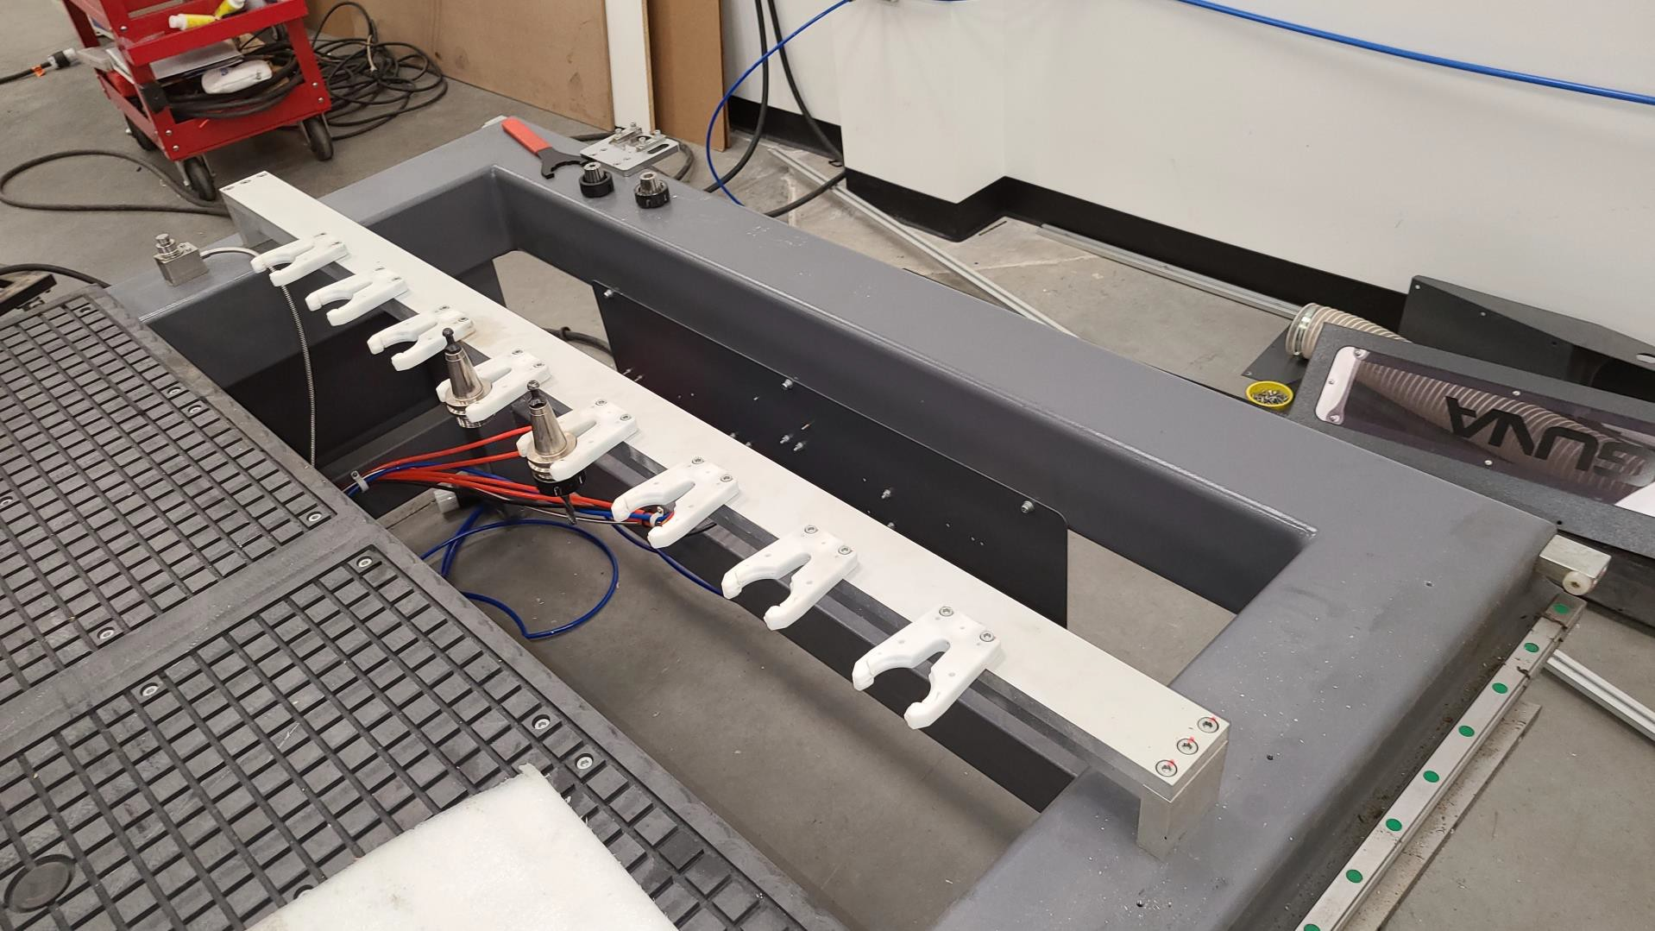
Bed or Machine Table

Vacuum Control Valves

6
Caterpillar Track

Machine Table: The bed of the machine consists of a heavy steel all-welded frame with a composite worktable that is machined for use with a vacuum pump. The table includes T-slots (and clamps) for special fixturing. The T-slots are used to clamp the job or fixtures to the bed.

Introduction to CNC Machines- Glossary & Definitions:

Gantry: The gantry straddles the bed and carries the Electro-Spindle and X and Z axes motion components. It is moved along the length of the bed by precision Helical Rack-and-Pinions with drive motors on each end of the gantry.

Electro-Spindle Assembly: The Electro-Spindle is moved along the gantry by a precision Helical Rack and-Pinion Ball Screw system that is controlled by the machine controller.

Frame: The frame is a heavy steel all-welded construction that provides a rigid platform for the other components and ensures accuracy as well as edge finish.
Electrical Control Cabinet: A standalone electrical control panel houses all of the major electrical components, including the machine controller.
Caterpillar Track: The caterpillar track runs along the side of the machine in a special trough and carries all the electrical cables and air lines.
Vacuum Control Valves: The machine has six (6) vacuum control valves that can be used to direct the vacuum to the vacuum table zones.
Tool Rack ATC: Tool changer includes eight (8) tool stations to accommodate a large range of tools. Each of the stations includes a ISO-30 gripper assembly, and station positions are controlled the Laguna Touch CNC controller.

Additional Instructions for the use of the Laguna SmartShop II CNC: Like all machines, there is danger associated with the machine. Injury can be caused by lack of knowledge or familiarity. Use this machine with respect. If normal safety precautions are overlooked or ignored, serious personal injury may occur. As the CNC is under the control of the onboard machine controller, it is important that you are clear of the cutter when operating the machine.

List of Additional Accessories:

Accessories, Machine Location, Unpacking & Installation-
Clamps
Cutters & Collets Memory Stick Dust Hose Clamps
Tool Holders Wrenches
Machine Location, Unpacking & Installation-

Machine Location & Guidelines:
Before unpacking the machine, select the area where the machine will be installed.
- There should be an area around the machine suitable for the length of material that will be machined as well as any loading and unloading requirements.
- There should be adequate lighting in the work area. The better the lighting, the better the productivity.
- The floor area under the machine should be flat and solid so that the machine frame does not shift as the gantry and tool plate traverse. Concrete is preferable.

- Consider the electrical and air supplies, vacuum pump location and dust collection when identifying an area to place the machine.

Unpacking the Machine:

Machine Location, Unpacking & Installation (Cont’d.)-
Unpacking the machine will require tin snips (to cut banding), a knife and an adjustable wrench. Follow the steps below:
  - Using the tin snips, cut the banding that is securing the machine to the pallet (if fitted).
  - WARNING: EXTREME CAUTION MUST BE USED BECAUSE THE BANDING CAN SPRING AND COULD CAUSE INJURY.
  - Remove the box from the CNC machine (if fitted) and any other packaging material. The parts ordered with the machine will be packed on or inside the machine. (Please note, the machine is heavy, and it is recommended that professional assistance [rigging] be used for unloading and placing the machine.).
  - Use a forklift with sufficient lifting capacity and forks that are long enough to reach the complete width of the machine before attempting to lift the machine.
  - Remove the securing bolts that attach the machine to the pallet (if fitted).
  - Approaching the machine from the side, lift the machine on the frame, taking care that there are no cables or pipes in the area of the forks.
  - Move the machine to the required position and install the leveling feet.
  - Then lower the machine gently to the floor.
  - Level the machine so that all the supporting feet are taking the weight of the machine and no rocking is taking place.

- Using Leveling Feet, Support and Level SS2 CNC Machine.

Machine Location, Unpacking & Installation (Cont’d.)-
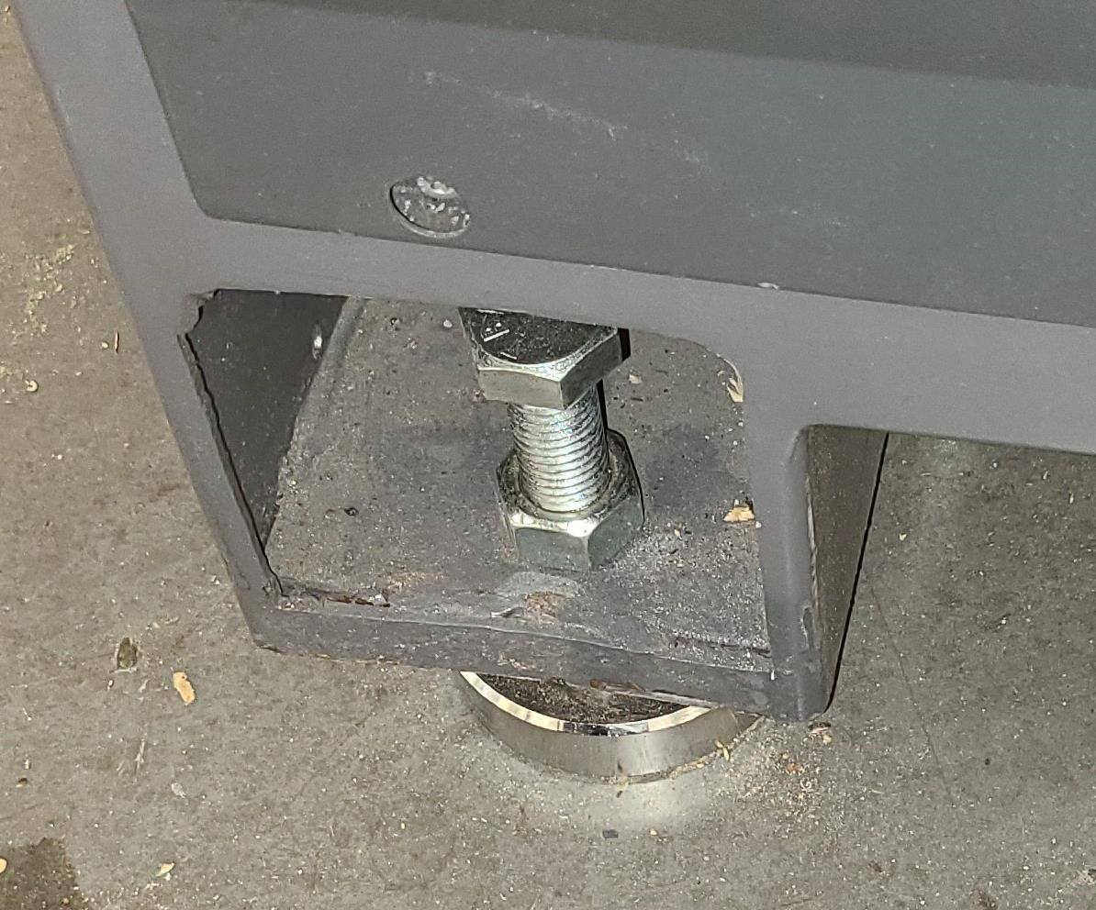
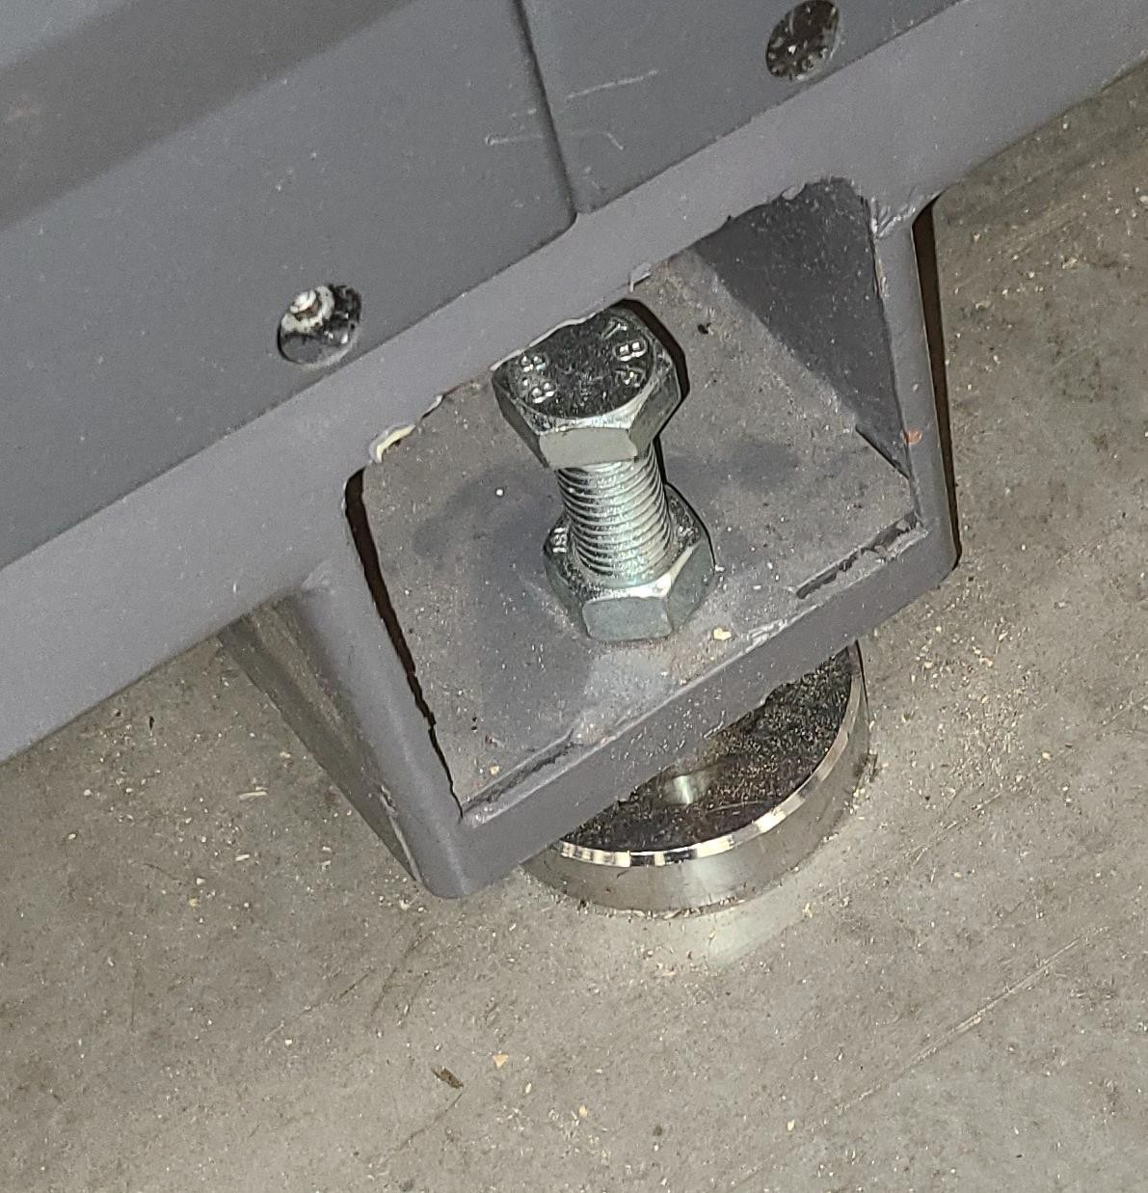
- SAFETY-Verify your shop/building has proper electrical supply. For confirmation on this, call customer service (1-800-234-1976) for diagrams verifying proper voltage & amperage requirements.

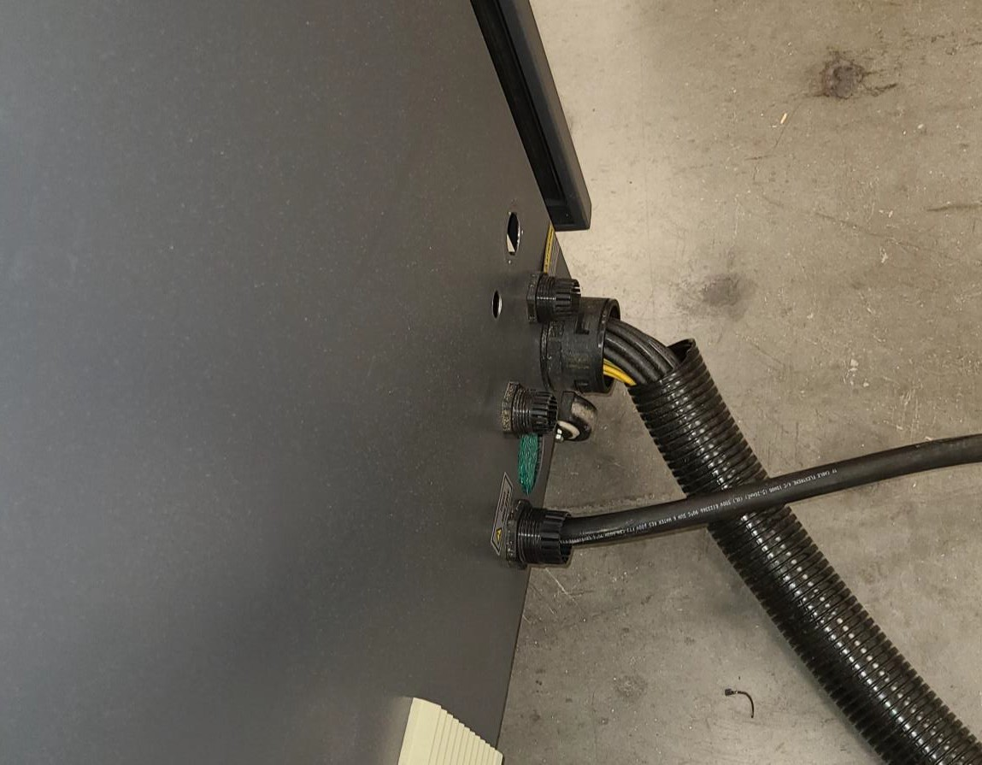
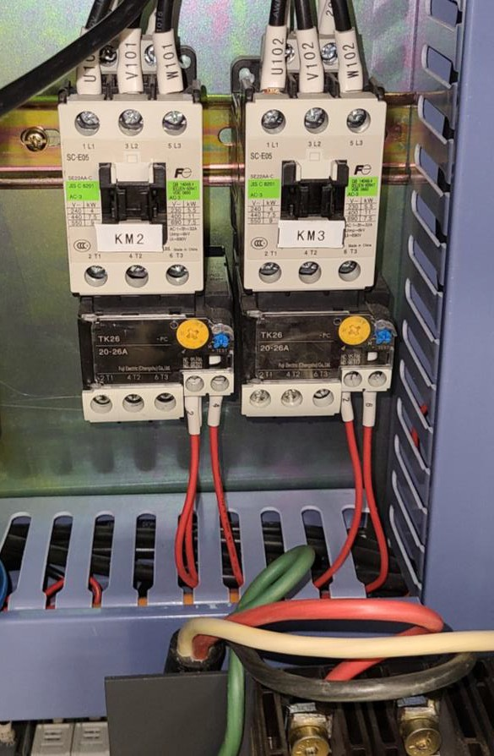
- Have a Certified Electrician wire from building breaker into control box (Does not need to hook

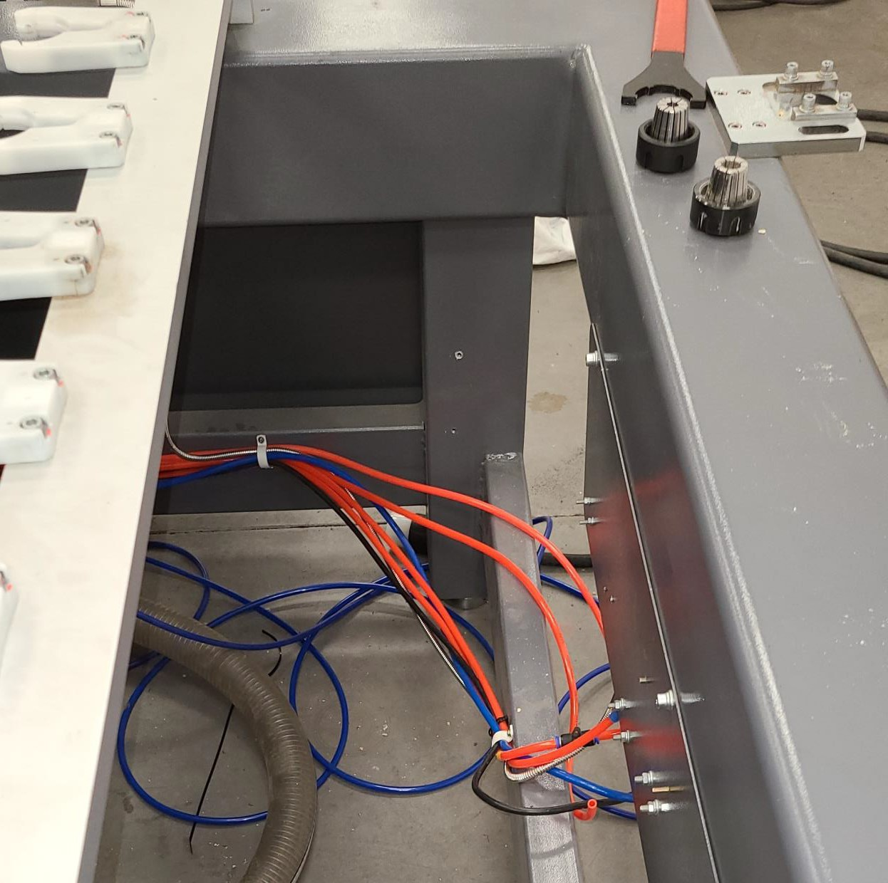
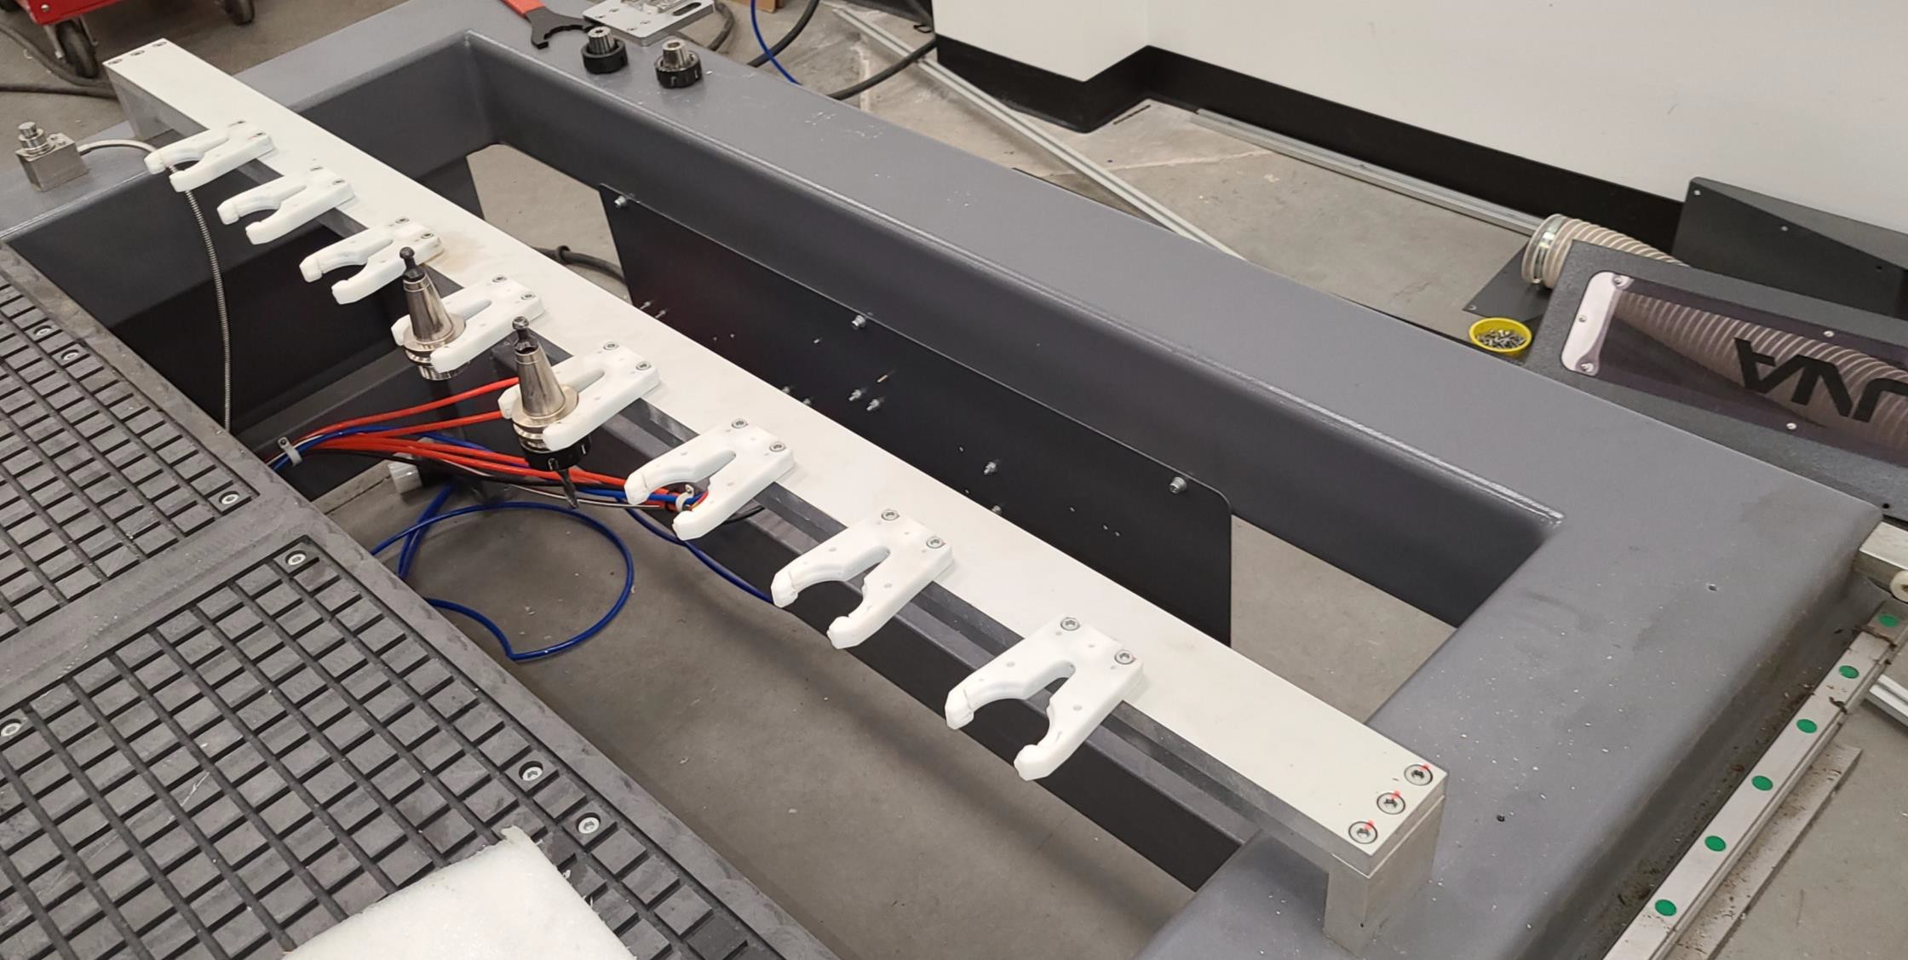

- Have a Certified Electrician wire from contactor to vacuum. (Run wires to vacuum and into box, we can wire once the wires are inside to the contactor. Vacuum has a Legend-Plate, electrician must decide wire size).

Machine Location, Unpacking & Installation (Cont’d.)-
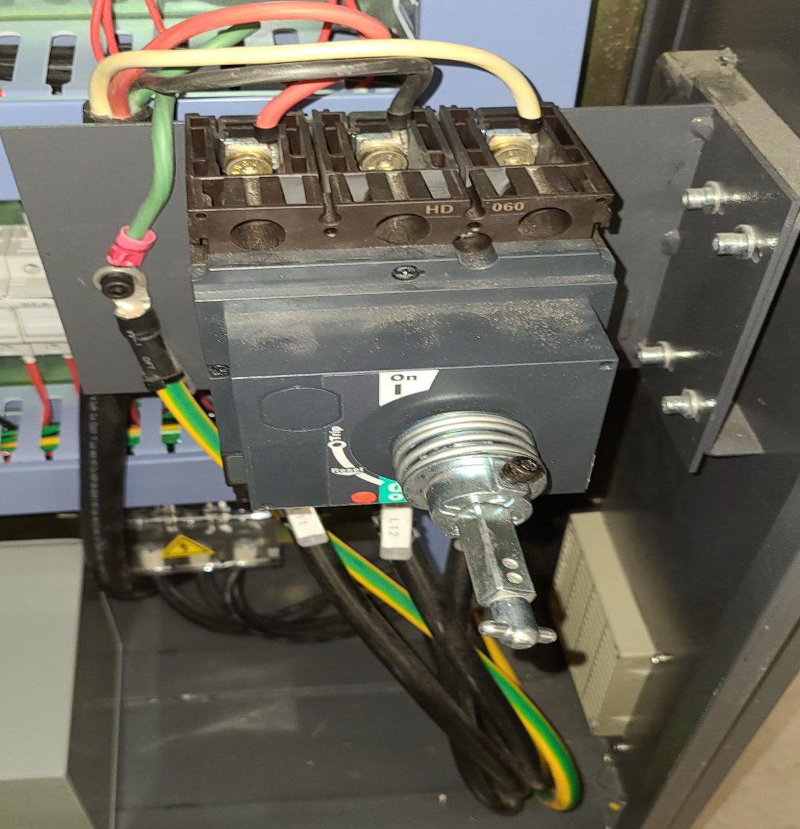
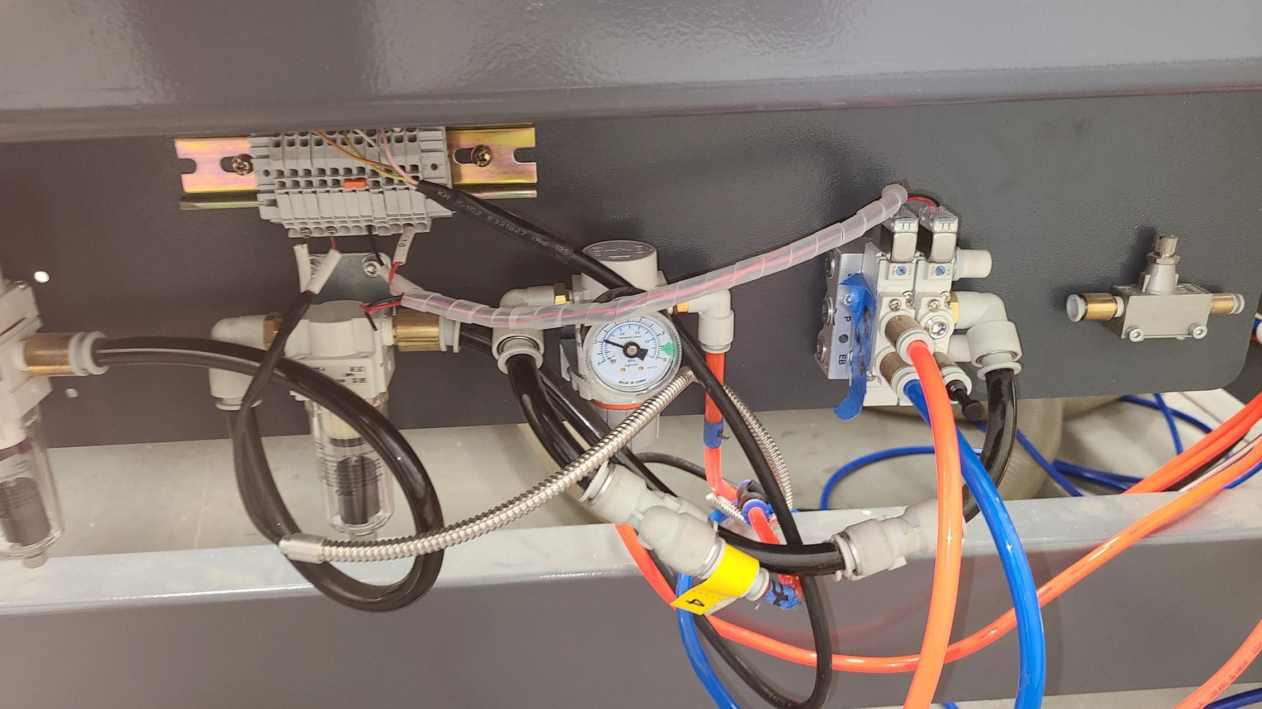
- Hook up clean, dry air to compressor on rear of machine underneath tool rack. (We do not supply inlet connector) Needs to be 85 PSI-95 PSI.

The machine is supplied with an air regulator. The input air regulator regulates the air pressure that is supplied to the machine. You will require an air supply that can deliver a constant minimum pressure of 85 psi. The input air regulator will need to be adjusted to 85 psi-90 psi once you have connected your air supply to the machine.

Machine Location, Unpacking & Installation (Cont’d.)-
Note: No air pipe is supplied, as the length will depend on your installation. To adjust the air pressure, pull the cap out (up) and rotate until the gauge reads the correct pressure. Once the pressure is adjusted, push the cap in.
Note: It is strongly recommended that 90 psi is supplied to the SmartShop II and that the regulator then be set to 85 psi. This will ensure that the machine always has the minimum required air pressure. The input regulator has a moisture trap that must be emptied each day.

Note: It is important that the air that is supplied to the machine is clean and dry. The machine will not perform consistently if the air is wet or dirty, as any dirt and moisture will block the valves. Wet, damp or dirty air will damage your machine and cause inconsistent performance.
Note: The pneumatic system does not need any type of lubricant. Some types of lubricant can damage the machine
and compromise the machine’s functions.
12
Note: During maintenance, always disconnect the air supply.

- Verify all items that were purchased and are on the sales order were sent and included. Verify there is a dust hood on the spindle. (If any items are missing, call customer service (1-800-234-1976 for verification on missing items so they may be sent out)

Machine Location, Unpacking & Installation (Cont’d.)-

- If providing own tooling, verify all proper tooling is available and readily available.
- Acquire adequate supply of materials to be cut during install including MDF Board for a Spoil Board to be placed
on tabletop (Spec. .75” – 1” Think).
- Install all software ahead of time. Review tutorials and gather basic understanding of software before technician arrives.
- “Read & Review Manuals” and try to familiarize with machine and basic components.
- Get 30W Oil for lubrication purposes (DO NOT USE WD-40 as a lubricant!).

- Fit the dust shroud to the two air cylinder rods and clamp in position with the clamping nuts.

Fitting the Dust Hose-
- Fit a 4-inch (not supplied) dust hose to the dust shroud and secure with the clamp. Ensure that it is tight; it is very inconvenient to have it fall off during production.
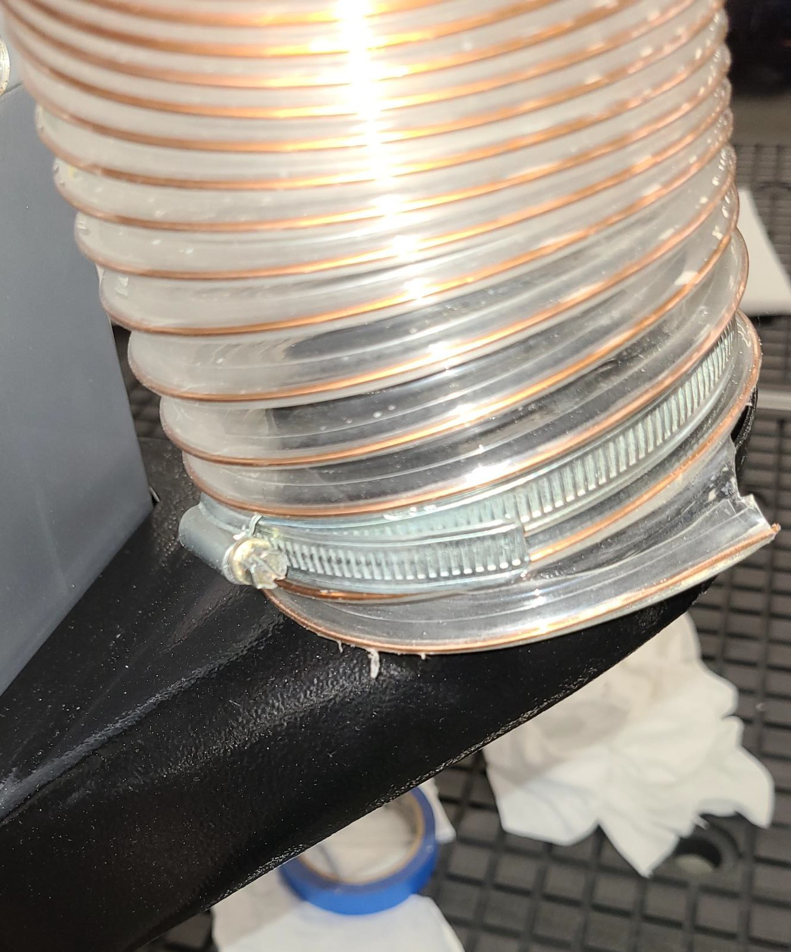
- The head of the machine will move across the complete table, and the dust hose will follow the head. If there is insufficient slack, the hose may break or damage the dust shroud. It is suggested that the hose be suspended from the ceiling of the shop with sufficient slack so that it will not restrict movement. It will also be out of the way and not causing a trip

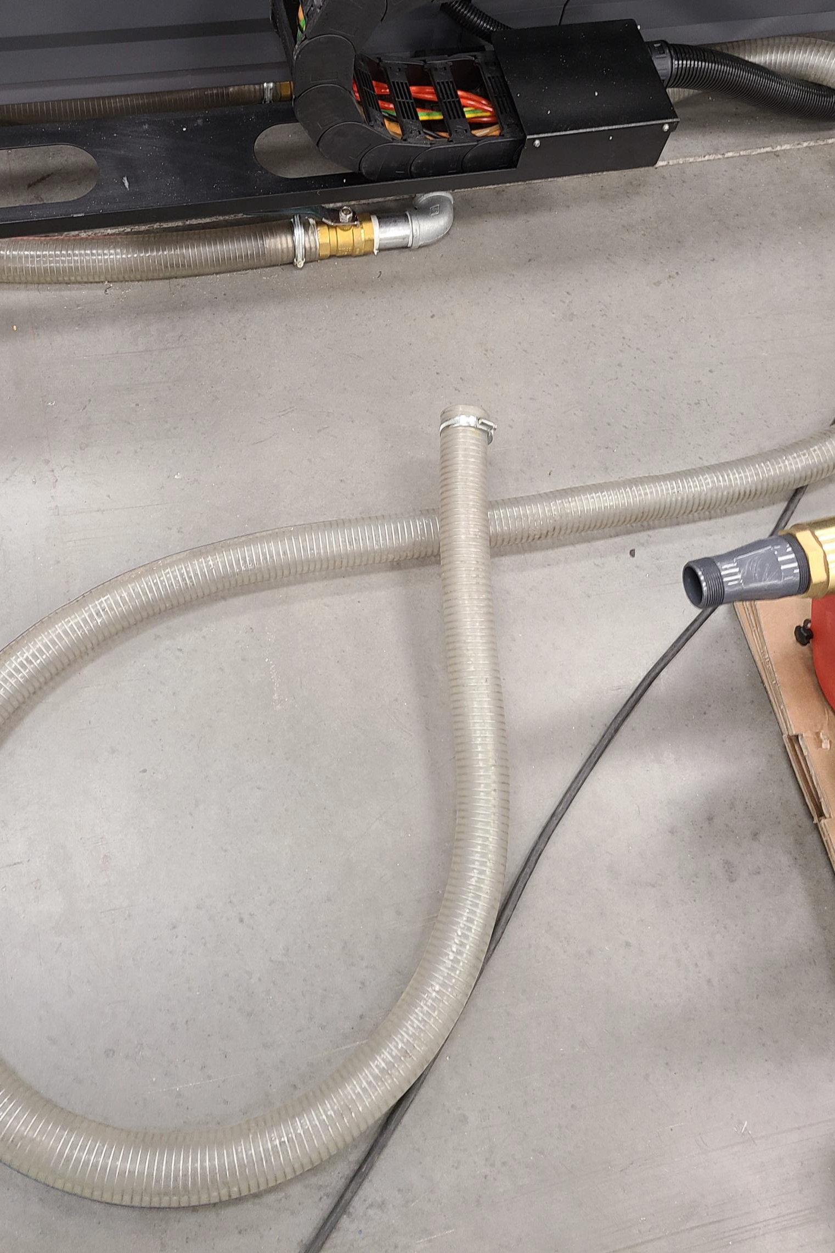

The machine is provided with a 2-inch hose for connection to the vacuum pump. The vacuum hose is connected to the manifold located under the table toward the front of the machine. Connect the free end to the vacuum hose to the vacuum pump inlet.

Connecting the Vacuum Pump-
Ensure that it is clamped securely.
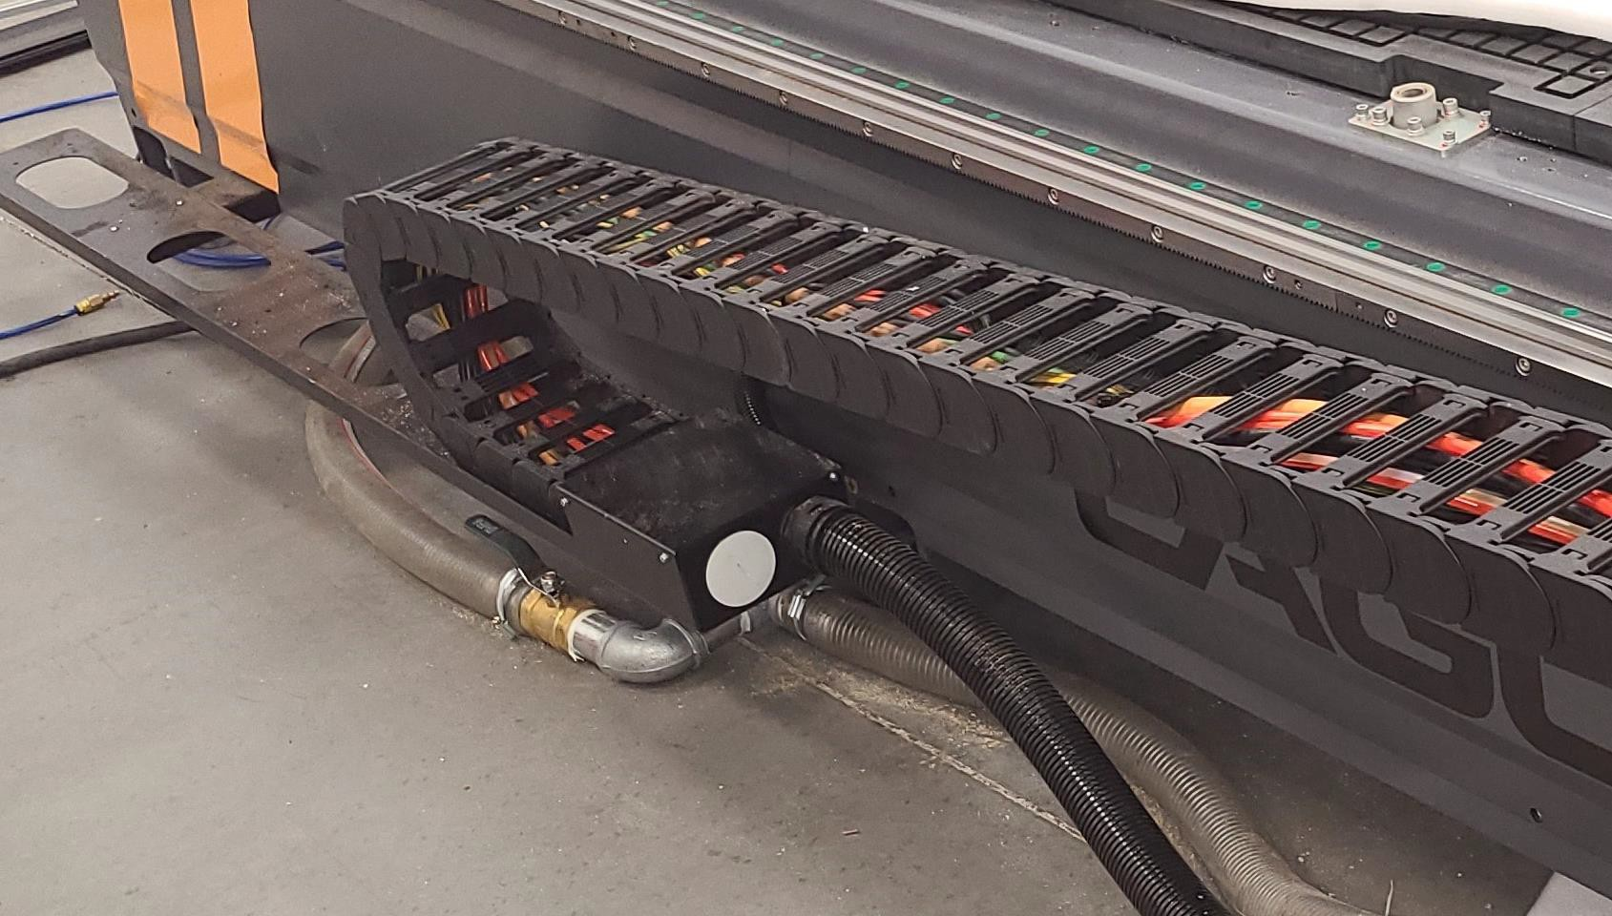

Installing the Router Bit in the Tool Holder Caution: Before changing or fitting the router bit, always disconnect the power to the machine.

Installing Router Bit-
- Select a router bit and its relevant collet.
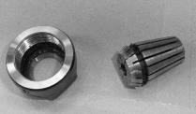
- Fit the collet into the spindle nut. Press the collet into the spindle nut until it snaps into place.
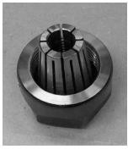
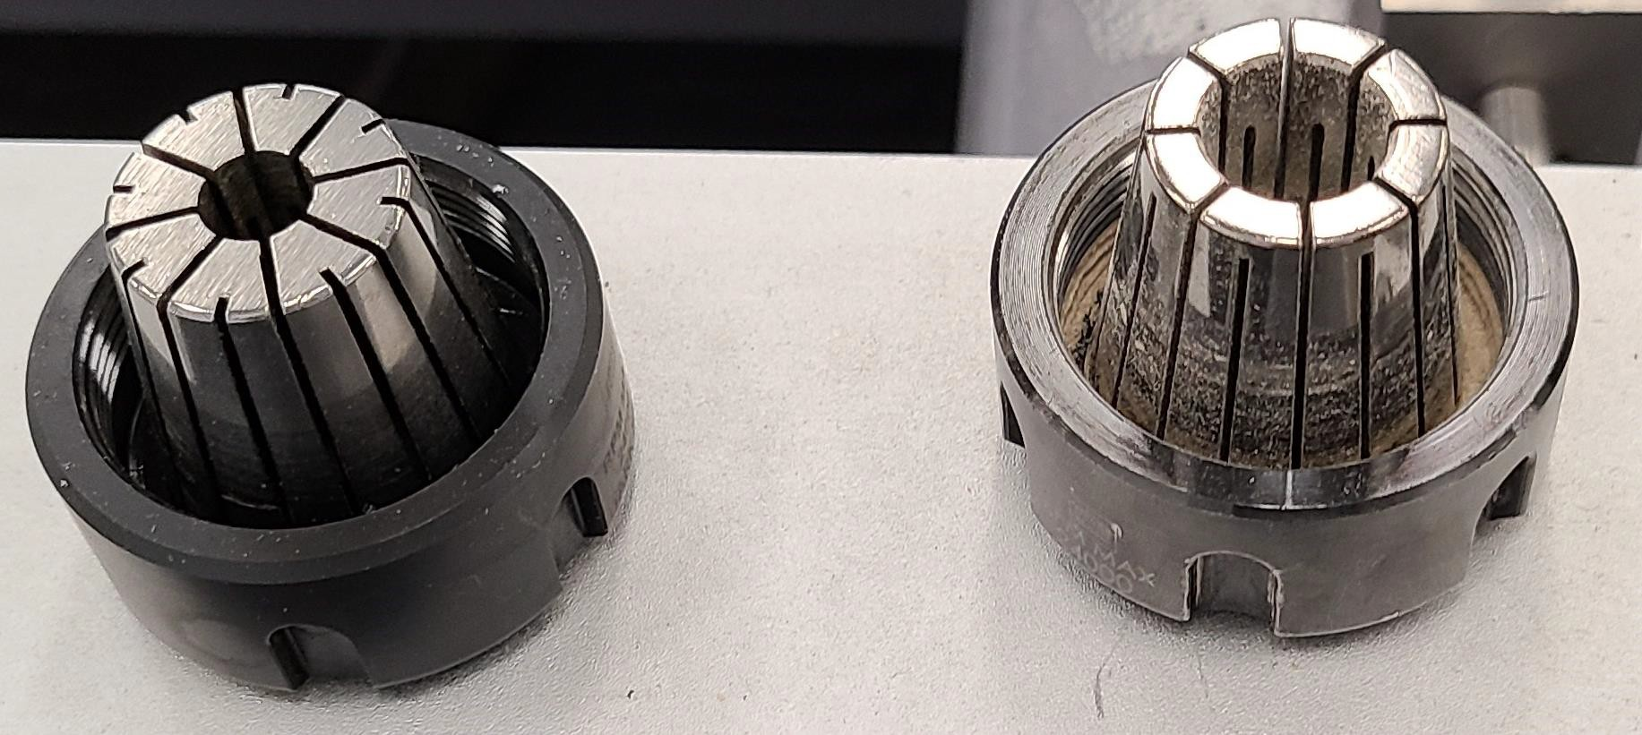
Note: The router bit must not be fitted into the collet until the collet has been fitted into the spindle nut. With the router bit fitted into the collet, the collet can not compress and “snap” into the spindle nut. The face of the collet and the face of the spindle nut will be close to flush.
Note: To remove the collet, hold the spindle nut and press the collet on the side. The collet will compress and pop out. Do not try to remove the collet while a cutter is fitted, as the collet will not compress and pop out.
- Fit the spindle nut and collet assembly onto the tool holder spindle thread by hand.
Press the bit into the collet. Note that the flute of the router bit must not be inside the collet and should be a minimum of 1/16" outside the collet. Hold the toolholder with the supplied wrench and tighten the collet with a second wrench. Do not over tighten.
Note: Use this process to install each of the router bits into the tool holders, being careful to use the correct collet size for each router bit. Note: Keep the collets clean and blow all dust out of the slots. Fine dust accumulates and may affect the clamping

The tool holder can be released from the spindle manually by pressing the “Green Manual Release Button” near the Electro- Spindle.

Manual Tool Release-
Note. When the “Green Manual Release Button” is pressed, the clamping is released and the tool will fall out. Place your hand so that the tool holder (not the cutter) is supported.
To manually insert a Tool Holder, hold the tool holder in the spindle taper while holding the green manual release button.
Once the green manual release button is released, the tool holder will be pulled up into the spindle hole and clamped in position.
***Please note that a small amount of air escapes from the spindle nose. This is used to blow any dust out of the spindle taper and is normal.
Note: Keep the tool holders clean, lubricated with Teflon.
Note: The spindle taper is susceptible to rust and must be kept clean and lubricated with a Teflon lubricant.
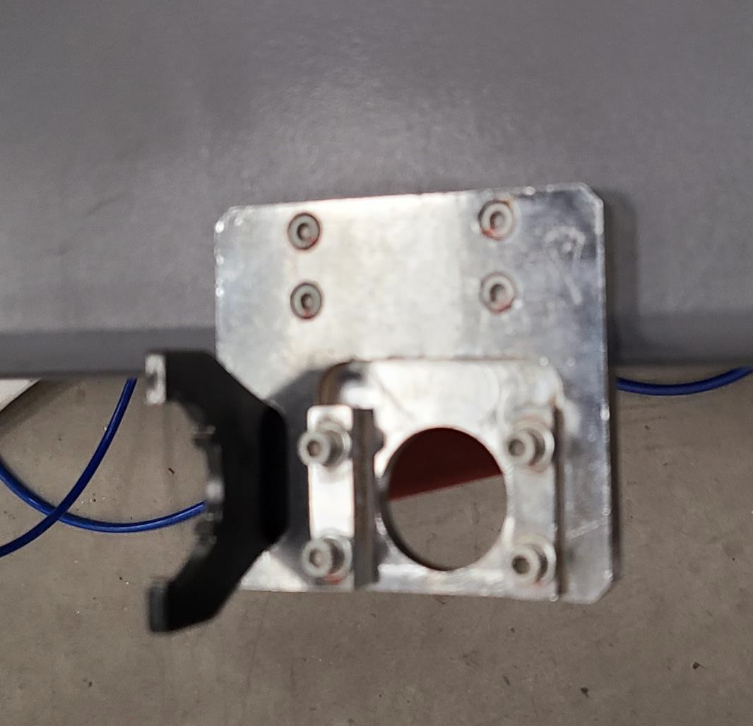
“Green Manual Release Button” Tool Holder & Tool Holder Bracket
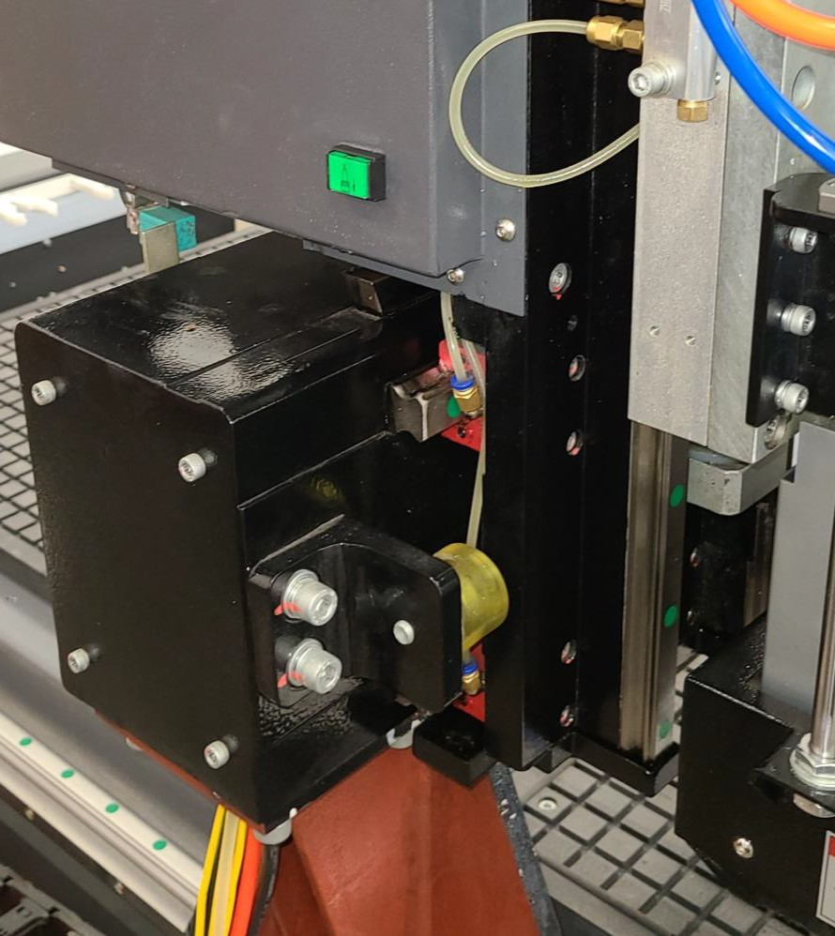

Selecting the Correct Router Bit-

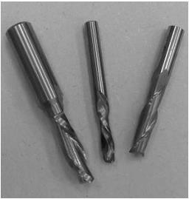
Straight Router Bits: These are the standard router bits that are commonly used with handheld routers and are readily available at home centers. They will work but will generally not produce the edge finishes that are available with the spiral designed router bits.
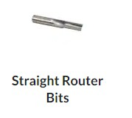
Up Shear Router Bits: These bits have flutes that are spiraled upward (a standard twist drill is an example of this type of bit). This bit design removes the chips from the kerf but has a tendency to chip the top surface, especially on veneers or melamine

Selecting the Correct Router Bit (Cont’d.)-

Ball Nose Router Bits: are a variation of the up shear bit design but have radiuses on the ends. These bits are typically used for 3D surfacing applications.
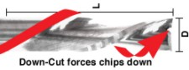

Down Shear Router Bits: These bits are similar to the up shear but with an opposite spiral that actually tends to pack the chips into the kerf. These bits prevent chipping the material surface, especially with veneers or melamine surfaces, and are an excellent choice for machining dadoes and other joinery that

Selecting the Correct Router Bit (Cont’d.)-

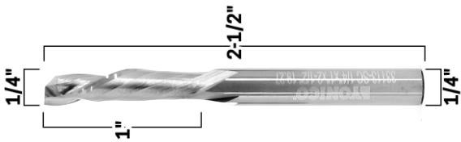
Combination (Compression) Router Bits: These bits combine the advantages of both up shear and down shear designs. The top section of the tool is down shear to prevent chipping the top surface of the material, and the lower part of the bit is up shear to prevent chipping the bottom surface of the material.
Compression Router Bits: are the preferred configuration for machining veneered plywood as well as melamine-
surfaced product. A variation of the bit is called the “Mortising Compression” router bit. With this bit, the
Up Shear portion of the bit is less than ¼" in length so that the bit can be used on ¼" veneered plywood and for dados.

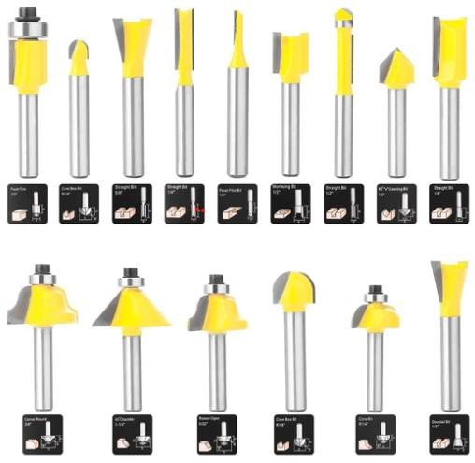
Selecting the Correct Router Bit (Cont’d.)-

Form Router Bits: Form Router Bits typically are available in standard profiles such as round over, ogee, cove, etc.

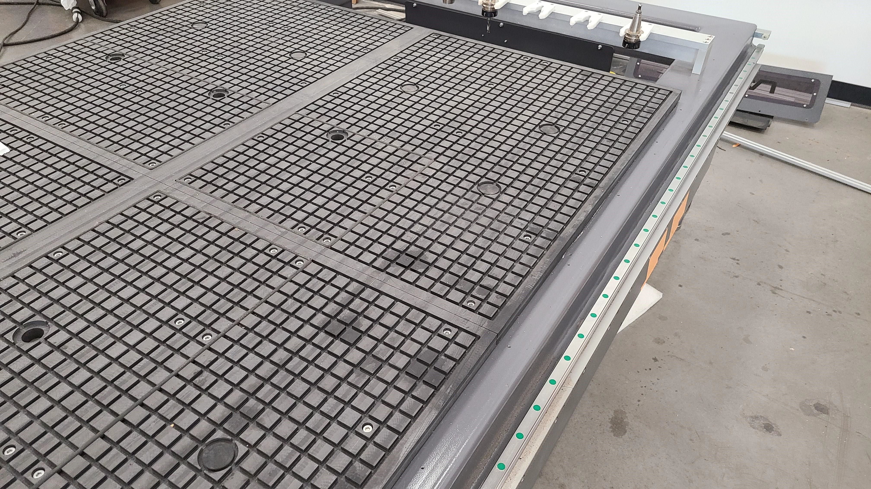

The more effective the vacuum table setup, the more secure the parts will be held in place. Follow the instructions below to obtain optimum results. The vacuum table has six (6) zones that can be used to configure the vacuum supply depending on the type of application.

Working With Vacuum Tables and Spoil Boards-

The table has vacuum ports for each zone that extract the air and generate the vacuum. The table also has grooves to ensure that the air is extracted evenly across the zones. Each zone is controlled by a valve located at the front of the machine.

Working With Vacuum Tables and Spoil Boards (Cont’d.)-

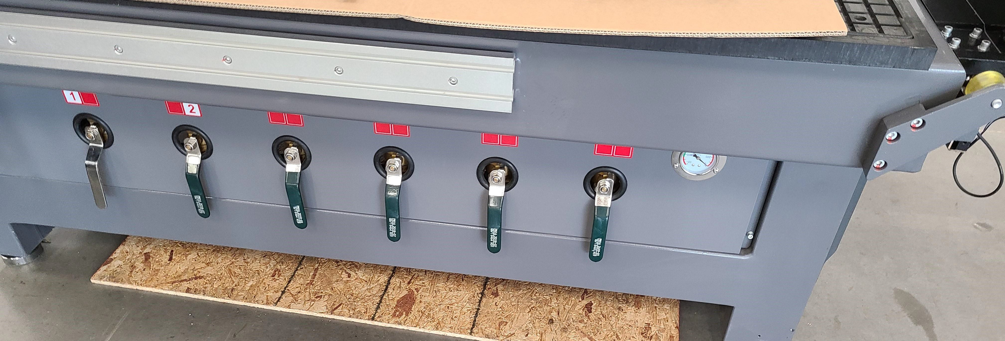
These valves controls the six “6”
Zones.

Spoil Board Material and Precautions For machining parts from panel materials (cabinets,

Working With Vacuum Tables and Spoil Boards (Cont’d.)-
fixtures, case goods, etc.) a technology referred to as “Flow-Through” fixturing is employed.
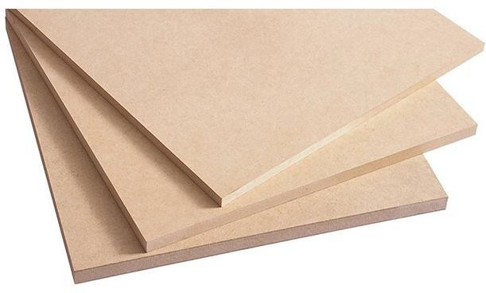
A sheet of porous material (usually MDF [Medium-Density Fiberboard]) is placed on top of the vacuum table.

Example: Medium-Density Fiberboard.

The panel material that is to be machined is actually placed on top of the MDF, and the vacuum passes through the MDF (Medium-Density Fiberboard) and holds the panel material down as it is machined.
***Great care should be taken when machining parts free to limit the extension of the tool

The purpose is to limit vacuum infiltration through grooves in the spoil board. This also allows the processing of various nests without any setup time on the machine.

Working With Vacuum Tables and Spoil Boards (Cont’d.)-

This technology is the basis for Nested-Based Manufacturing (NBM)-Nested-based manufacturing refers to a system used to efficiently produce groups of rectangular and non-symmetrical parts from flat material, such as composite and solid wood panels or plastic sheets. The components are “Nested” together on the material
(see the photo below), which means they are positioned in a pattern that achieves the best possible material utilization.
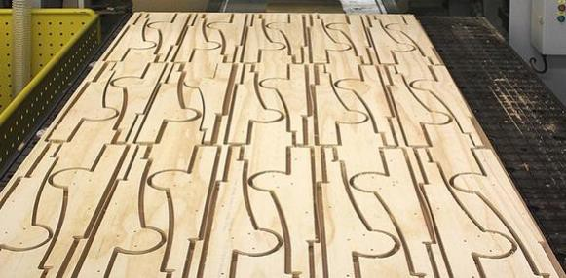

Functions of the Spoil Board-

Working With Vacuum Tables and Spoil Boards (Cont’d.)-
- To protect the vacuum table from damage. The cutter extends only a few thousandths of an inch past the material thickness. Without the spoil board, the cutters could damage the surface of the vacuum table.
- To transfer the vacuum from the table to the job. This means that the spoil board has to be porous to allow air flow to the panel material. Low cost MDF (Medium-Density Fiberboard) has proven to be a very good material for this purpose.
- To provide a “Zero Setup” environment for processing panel products.
Spoil Board Preparation-
When MDF is sourced for the spoil board, it should be (>) greater than ¾” of an inch.
Contrary to what might seem logical, the thicker the MDF the better the suction that is created.
“Flow-Through” fixturing maintains a careful balance between air flow through the MDF and the infiltration that
occurs as the kerfs (Grooves or Notches made by a cutting tool) are machined.
***It is not recommended that the spoil board material be is thicker than 1 inch***.
The MDF manufacturing process causes the top and bottom surfaces of the material to be compressed. It is necessary, therefore, to remove the compacted top and bottom surfaces.
This process is termed “fly-cutting” and requires the removal of approximately 0.060" from each surface. This
process also ensures that the machining plane and spoil board surface are parallel.

The spoil board (MDF) edges are also very porous, and sealing them can improve the part holding ability.

Working With Vacuum Tables and Spoil Boards (Cont’d.)-
***Hard Candle Wax-is an excellent product for sealing the spoil board edges because it contains no water and is very easy to apply***.
Never use a water-based product to seal the edges of the board, as this will make the board expand and become unsuitable for use as a spoil board.
Even some glue products contain water and can affect the edges of the spoil board.
Note: Do not confuse flatness with bow. If the board is bowed, the vacuum may not pull the board flat on the table. Never try to use a bowed MDF panel as a spoil board.

Use the following Procedure for preparing the Spoil Board:

Working With Vacuum Tables and Spoil Boards (Cont’d.)-
- Cut the spoil board to the size of the table of the machine, if necessary.
- Apply gasketing (The action of fitting or sealing with a gasket) to the outermost vacuum grooves on the table surface.
- Make sure that the table is clean and free from sawdust and dirt.
- Place the spoil board on the vacuum table, being careful not to displace the vacuum gasketing.
- “Turn On” the vacuum pump and check for leaks.
- Fly cut the surface of the spoil board, removing approximately 0.060 Inch" to ensure that the compressed surface of the material is removed.
- Once the material surface is machined, “Turn Off” the vacuum pump, turn the spoil board over and repeat the process for the other side. (***Remember to ensure that the table and

Spoil Board Use Each time a new job is machined, there may be shallow cuts into the spoil board in the areas that the cutter passes through the material.

Working With Vacuum Tables and Spoil Boards (Cont’d.)-
Prior to placing a sheet of material on the spoil board, clean with a hand-held blower or vacuum cleaner.
Dirt under the material will reduce the vacuum, and in extreme cases, parts may move during the machining process. In general, keeping everything clean is the key to achieving good, repeatable results.
Precautions Regarding Spoil Boards-
The spoil board is porous and will absorb moisture. As moisture is absorbed, the dimensions of the board will change.
In general, this will not be a problem, as the changes from day to day are not that excessive and will typically be over the complete board.

There are, however, exceptions-

Working With Vacuum Tables and Spoil Boards (Cont’d.)-
- It is a good practice to keep material on the top surface of the spoil board overnight to prevent warpage due to uneven moisture absorption by the material.
- Once a spoil board has been used and has kerf cuts that resulted from machining parts, it is a good idea to fly cut the surface again. This time it should only be necessary to remove 0.015" of material since the only purpose is to produce a smooth, flat surface, and that amount should remove the machining marks.
- The spoil board must cover the complete table and sit on the flats around the table. If the spoil board does not cover all the vacuum slots, the vacuum may be lost or not exist and the panel material will not be pulled down onto the spoil board effectively.

The vacuum table has T-slot mounting devices incorporated into the tables to enable fixtures and material blanks to be clamped directly to the table.

Vacuum Table T-Slots & Automatic Tool Changer (ATC)-
Clamps are provided, but the table must be protected with a backer when using jacking bolts. If the
jacking bolts come in contact with the composite or aluminum of the table, the materials could be damaged. The backer should be as large as possible to spread the load on the machine table.
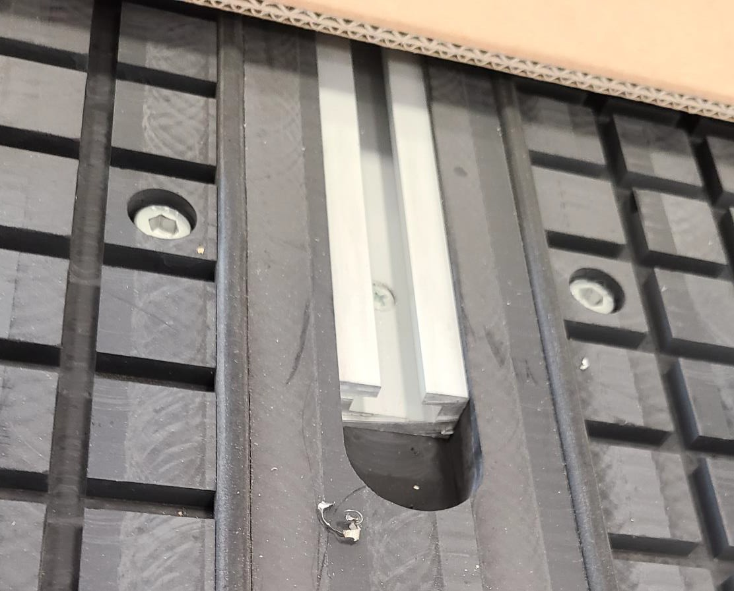
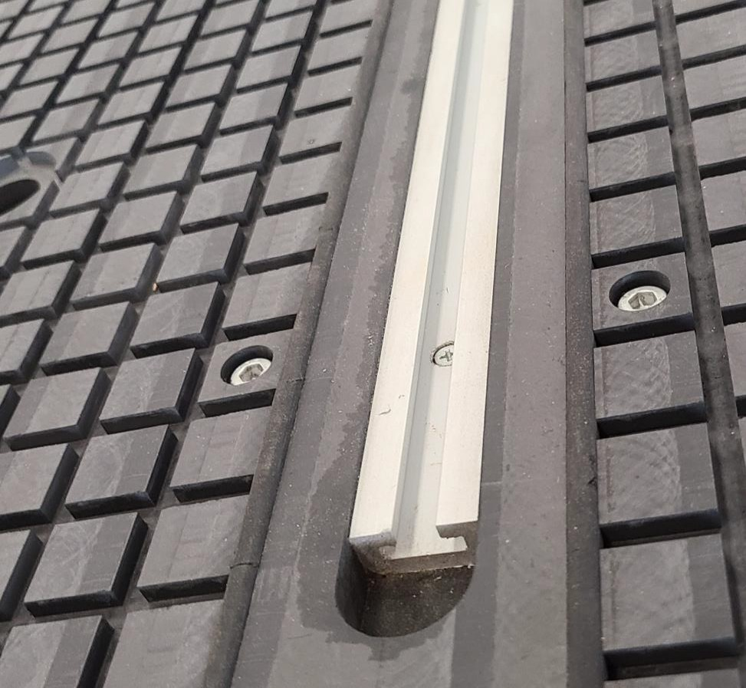
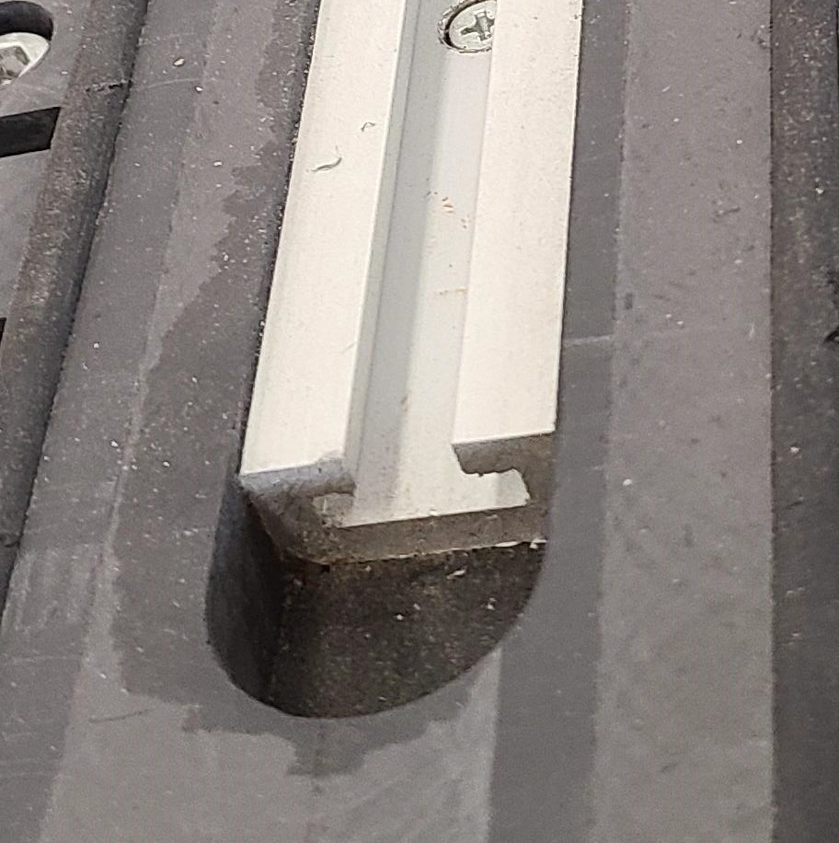
T-Slot Mounting Devices

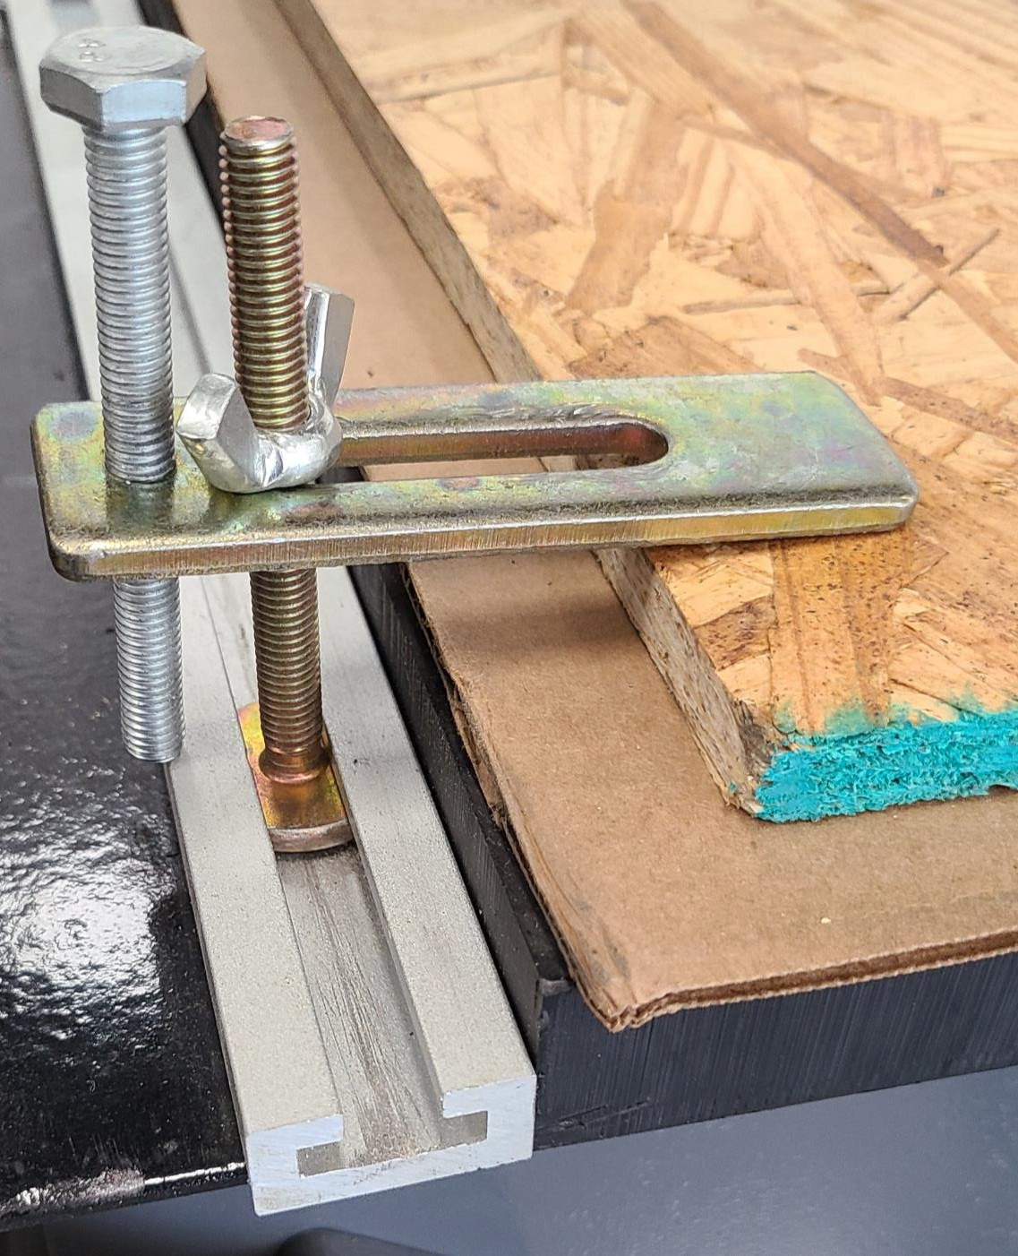
T-Slot Clamps
Clamp
Backing

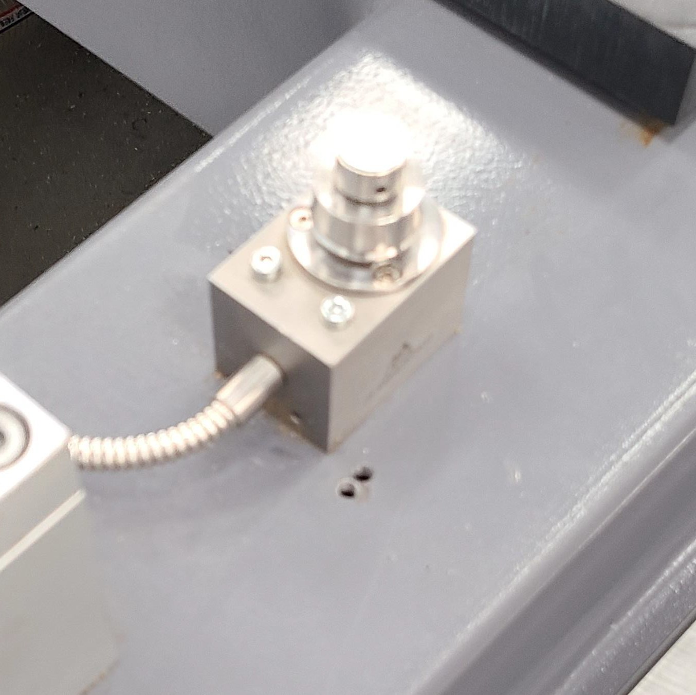
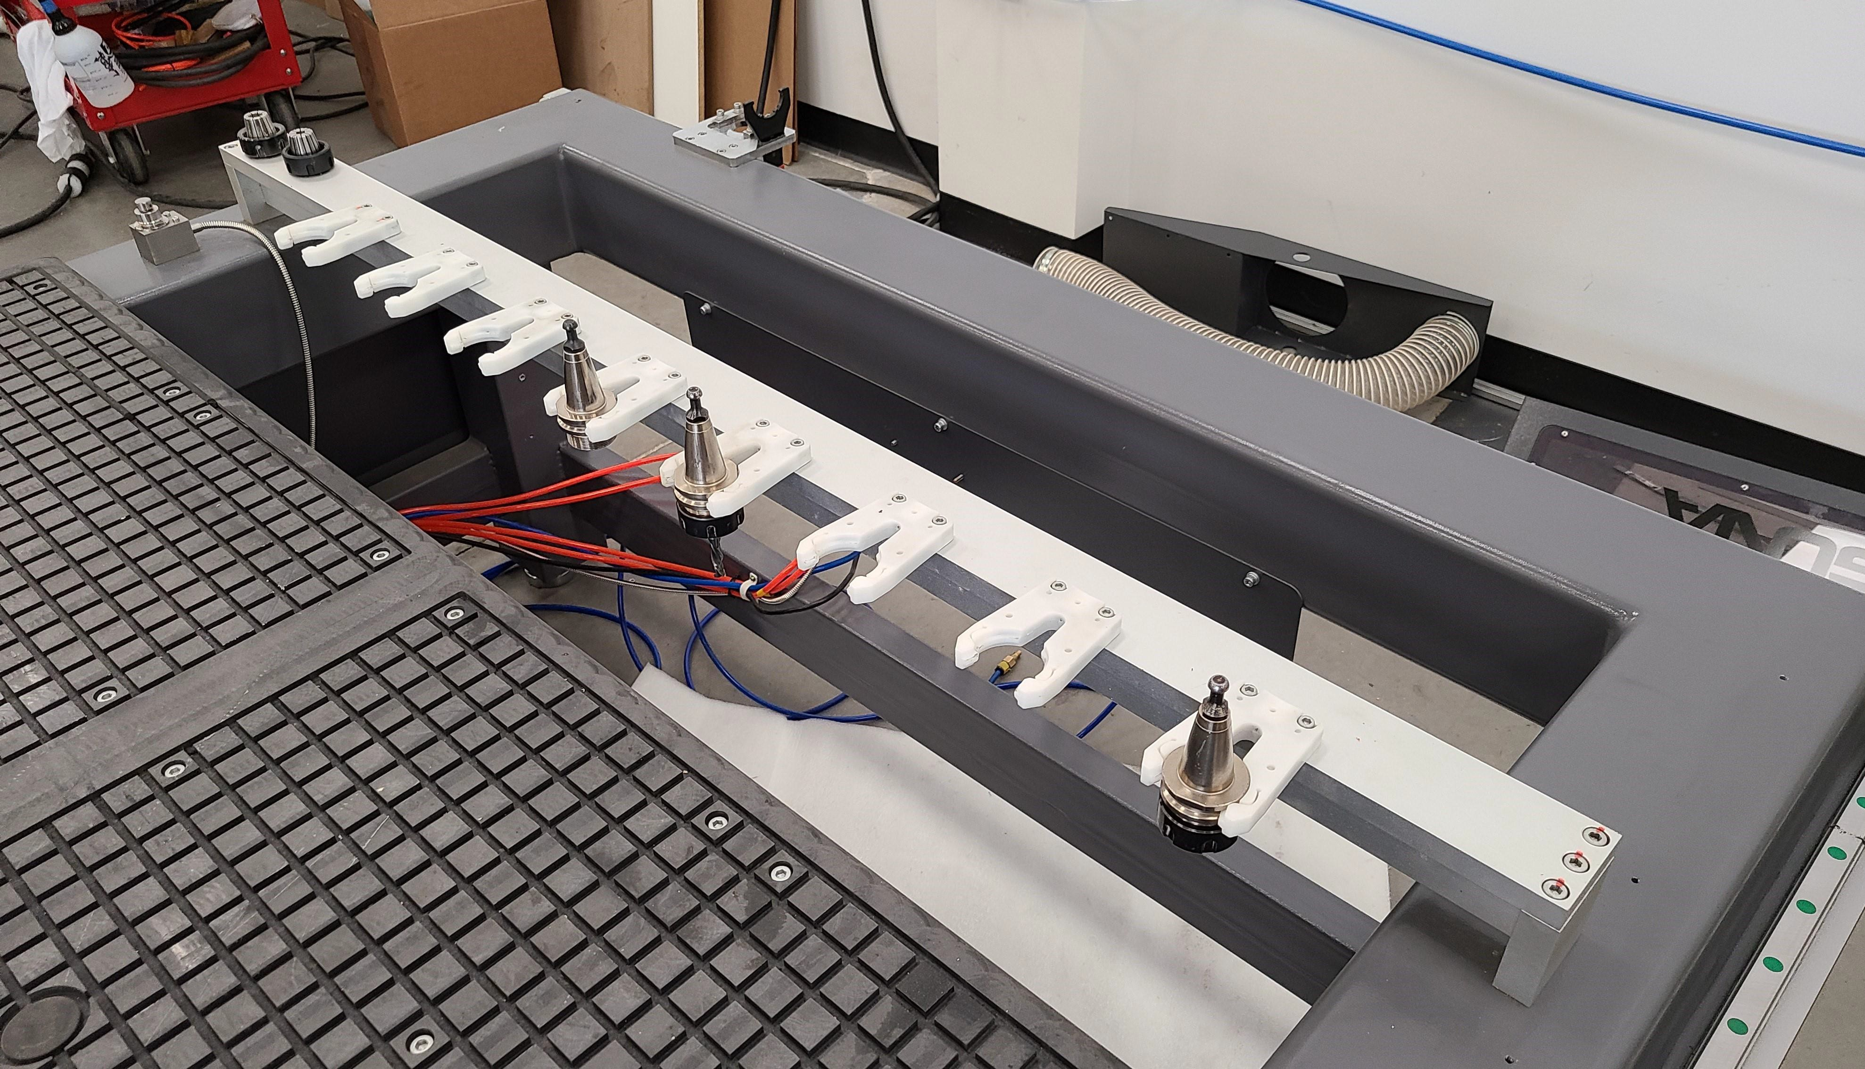
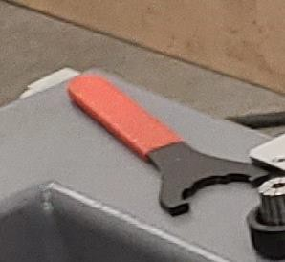
Vacuum Table T-Slots & Automatic Tool Changer (ATC) Cont’d.-

ATC Bracket & Tool

Automatic Tool Changer-ATC

Tool Touch Off-TTO
The Automatic Tool Touch-Off system (described later in this manual) is used to measure the tool lengths automatically.

Automatic Tool Changer (ATC)
The Automatic Tool Changer consists of a group of tool holder
grippers mounted to a rigid bar. The machine control knows the location of each of the grippers and will load and unload tools automatically as required by the program.

Safety Rules As with all machinery, there are certain hazards involved with the operation and use. Using it with caution will considerably lessen the possibility of personal injury. However, if normal safety precautions are overlooked or ignored, personal injury to the operator may result. If you have any questions relative to the installation and operation, do not use the equipment until you have contacted your supplying distributor.
Safety Rules-

Read carefully before operating the machine:
- Keep the working area clean and be sure adequate lighting is available.
- Do not wear loose clothing, gloves, bracelets, necklaces or ornaments. Wear face, eye, respiratory and body protection devices as indicated for the operation or environment.
- Be sure that the power is disconnected from the machine before tools are serviced or an attachment is to be fitted or removed.
- Never leave the machine with the power on.
- Do not use dull, gummy or cracked cutting tools.
- Be sure that the keys and adjusting wrenches have been removed and all the nuts and bolts are secured.

- Most large machinery will be delivering on a tractor trailer 48'-53' long. Please notify Sales Representative with any Delivery Restrictions.
Delivery Protocol-

- Customer is required to have a forklift (6000lb. or larger is recommended) with 72" forks or fork extensions and operator.

- Note any visible damage, torn packaging, scuffs or any abnormal marks on the delivery receipt or Bill of Lading (BOL).

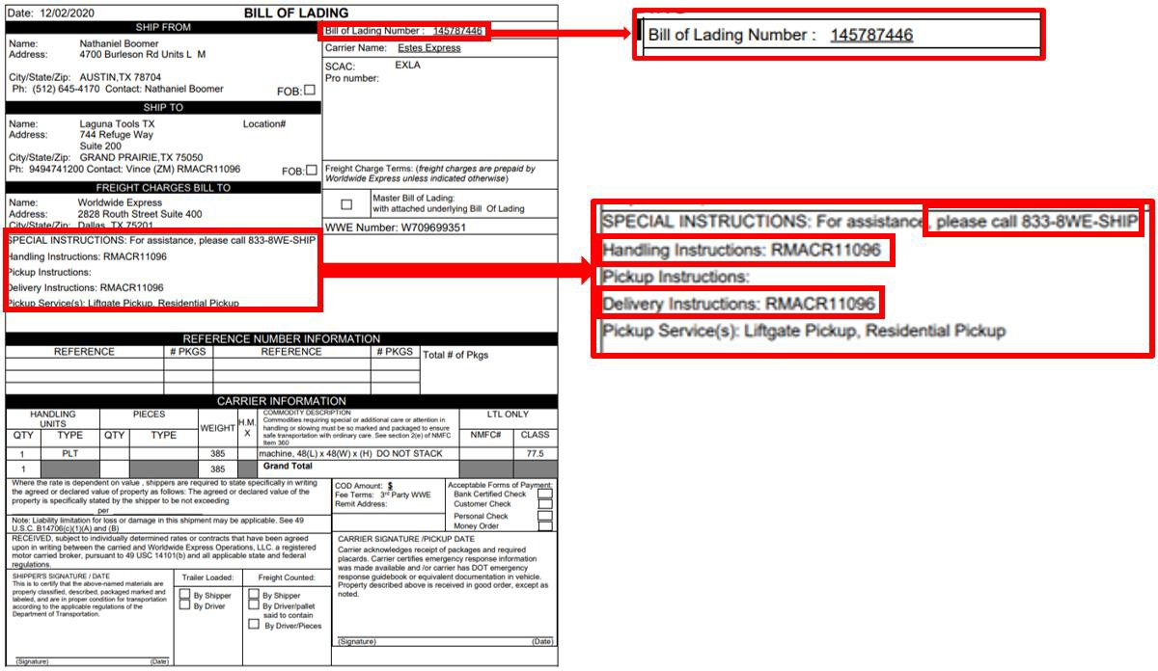

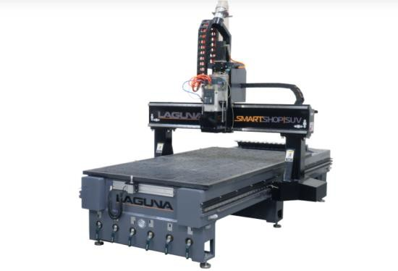
Parts & Service

Dealer Machinery Warranty
Laguna Tools Warranty-
New woodworking machines sold by Laguna Tools carry a two-year warranty effective from the date of dealer invoice to customer/end-user. Machines sold through dealers must be registered with Laguna Tools within 30 days of
purchase to be covered by this warranty. Laguna Tools guarantees all new machine sold to be free of manufacturers’ defective workmanship, parts and materials. We will repair or replace, without charge, any parts determined by Laguna Tools, Inc. to be a manufacturer’s defect. We require that the defective item/part be returned to Laguna Tools with the complaint. The end-user must request an RMA (return material authorization) number from Customer Service and include the (RMA) number with any and all returned parts/components requesting warranty coverage.* Any machines returned to Laguna Tools must be returned with packaging in the same manner in which it was received. If a part or blade is being returned it must have adequate packaging to ensure no damage is received during shipping. In the event the item/part is determined to be damaged due to lack of maintenance, cleaning or misuse/abuse, the customer will be responsible for the cost to replace the item/part, plus all related shipping charges. This limited warranty does not apply to natural disasters, acts of terrorism, normal wear and tear, product failure due to lack of maintenance or cleaning, damage caused by accident, neglect, lack of or inadequate dust collection, misuse/abuse or damage caused where repair or alterations have been made or attempted by others.
**NOTE: Issuing an RMA number is for referencing materials and issues, it does NOT indicate warranty acceptance/conformity.

CNC Limited Warranty
Laguna Tools Warranty-
New CNC machines sold by Laguna Tools carry a one-year warranty effective from the date of shipping. Laguna Tools guarantees all new machine sold to be free of manufacturers’ defective workmanship, parts, and materials. We will repair or replace without charge, any parts determined by Laguna Tools, Inc. to be a manufacturer’s defect. We require that the defective item/part is determined to be damaged due to lack of maintenance, cleaning or misuse/abuse, the customer will be responsible for the cost to replace the item/part, plus all related shipping charges. This limited warranty does not apply to natural disasters, acts of terrorism, normal wear and tear, product failure due to lack of maintenance or cleaning, damage caused by accident, neglect, lack of or inadequate dust collection, misuse/abuse or damage caused where repair or alterations have been made or attempted by others.
Laguna Tools, Inc. is not responsible for additional tools or modifications sold or performed (other than from/by Laguna Tools, Inc.) on any Laguna Tools, Inc. woodworking machine. Warranty maybe voided upon the addition of such described tools and/or modifications, determined on a case-by-case basis. Software purchased through Laguna Tools, Inc., is not covered under this warranty and all technical support must be managed through the software provider. Normal user alignment, adjustment, tuning and machine settings are not covered by this warranty. It is the responsibility of the user to understand basic woodworking machinery settings and procedures and to properly maintain the equipment in accordance with the standards provided by the manufacturer.
Parts under warranty are shipped at Laguna Tools, Inc.’s cost either by common carrier, FEDEX ground service or a similar method. Technical support to install replacement parts is primarily provided by phone, fax, e-mail or Laguna Tools Customer Support Website. The labor required to install replacement parts is the responsibility of the user. Laguna Tools is not responsible for damage or loss caused by a freight company or other circumstances not in our control. All claims for loss or damaged goods must be notified to Laguna Tools within twenty-four hours of delivery.

****Please contact our Customer Service Department for more information. Only NEW machines sold to the original owner are covered by this warranty. For warranty repair information, call 1-800-332-4094. Copyright 2013 Laguna Tools, Inc. **Warning – no portion of
these materials may be reproduced without written approval from Laguna Tools, Inc.

Laguna Tools Warranty-

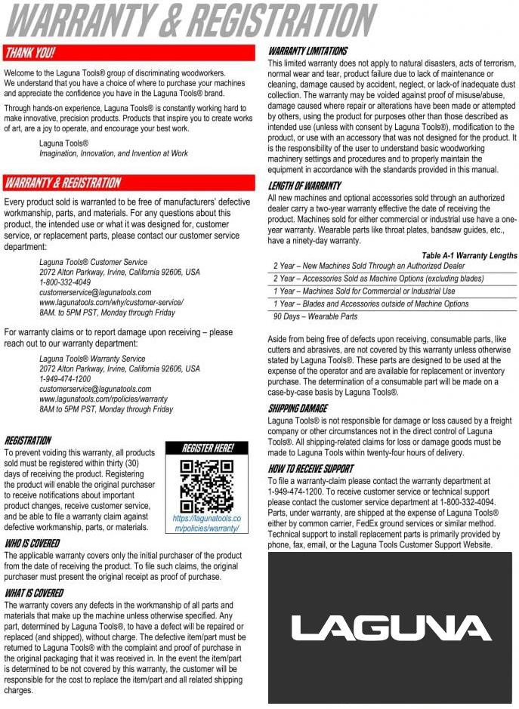

No Modifications Allowed or Sold.
Laguna Tools Warranty-
Laguna Tools, Inc. is not responsible for additional tools or modifications sold or performed (other than from/by Laguna Tools, Inc.) on any Laguna Tools, Inc. woodworking machine. Warranty maybe voided upon the addition of such described tools and/or modifications, determined on a case-by-case basis. Normal user alignment, adjustment, tuning and machine settings are not covered by this warranty. It is the responsibility of the user to understand basic woodworking machinery settings and procedures and to properly maintain the equipment in accordance with the standards provided by the manufacturer. Parts, under warranty, are shipped at Laguna Tools, Inc.’s cost either by common carrier, FEDEX ground service or a similar method. Technical support to install replacement parts is primarily provided by phone, fax, e-mail or Laguna Tools Customer Support Website. The labor required to install replacement parts is the responsibility of the user.
Laguna Tools is not responsible for damage or loss caused by a freight company or other circumstances not in our control. All claims for loss or damaged goods must be notified to Laguna Tools within twenty-four hours of delivery. Please contact our Customer Service Department for more information. Only new machines sold to the original owner are covered by this warranty.
For warranty repair information, call 1-800-332-4094.

Dealer Machinery Warranty
Laguna Tools Packaging/RMA Procedures-
**Any machines returned to Laguna Tools must be returned with packaging in the same manner in which it was received. If a part or blade is being returned it must have adequate packaging to ensure no damage is received during shipping. In the event the item/part is determined to be damaged due to lack of maintenance, cleaning or misuse/abuse, the customer will be responsible for the cost to replace the item/part, plus all related shipping charges.
We require that the defective item/part be returned to Laguna Tools with the complaint. The end-user must request an RMA (Return Material Authorization) Number from Customer Service and include the (RMA) number with any and all returned parts/components requesting warranty coverage.

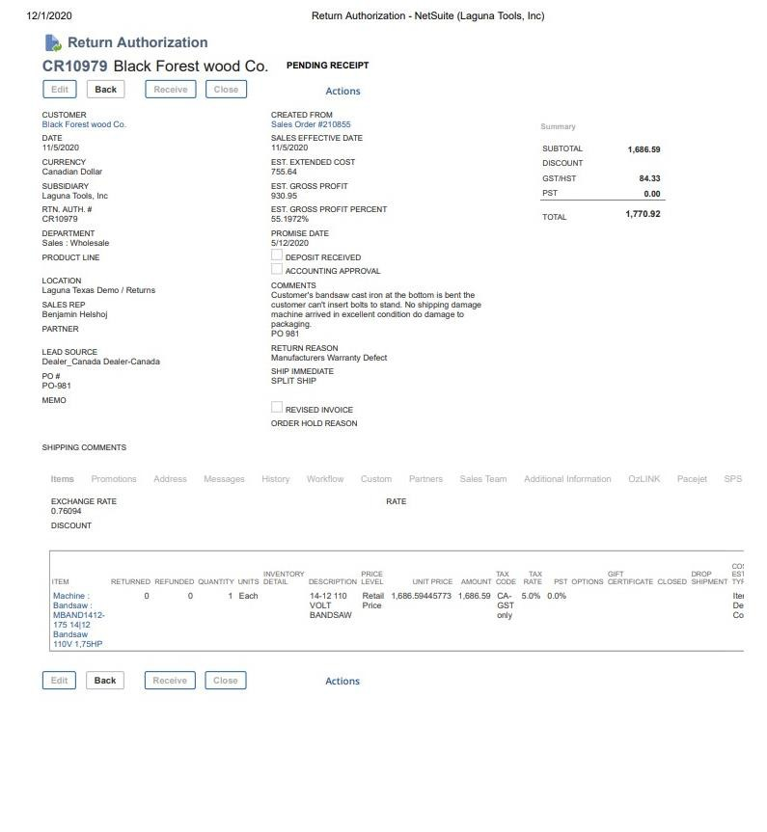
Laguna Tools Packaging/Laguna Tools RMA Example-

RMA #

Laguna Tools Packaging/Laguna Tools BILL of LADING Example-

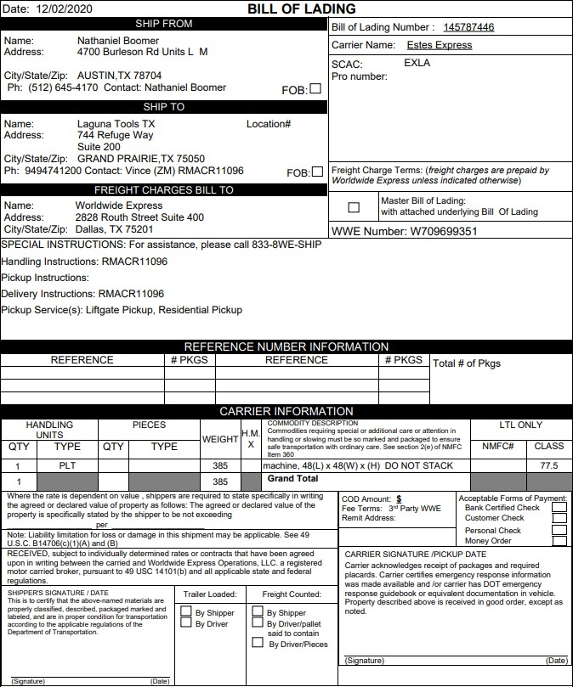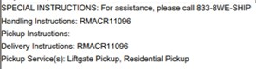

42

